Baja SAE at Virginia Tech

Final Report | 5/3/2019

Rear Suspension Skunkworks

Katie Brown Tyler Schulok

Joshua Clark Hagan Deely

Jaisohn Kim Matt Euliano

Aric Porter Ansh Kapoor

Andy Randell Nadja Ross

Andrew Touzinsky Yashasvi Shanker Sharma

Bob Zhang Eugenia Walk

Viktor Zorya

Team #46 | Faculty Advisor: Dr. John Ferris



# **Summary**

Historically, our organization has fully redesigned our competition vehicle with each academic year. This has limited the team’s success at competition, as designs rarely reach maturity. To combat this issue we have changed our organizational structure to promote the pursuit of more technically complex projects. Groups of seniors will pursue large projects through ME 4015 and ME 4016 with no required connection to the competition vehicle for that academic year, but with the ultimate goal that their system be implemented on a competition vehicle. This guarantees the team will dedicate resources to these projects and provide structure. Two groups exist this year: Rear Suspension and Skunkworks.

The Rear Suspension group was given the task of re-evaluating our rear suspension architecture from the ground up. Skunkworks goal was more vague: simply find a way to improve the vehicle, even if it is unfamiliar and/or high risk. Translating these goals to a set of customer needs and target specifications, each group generated several conceptual solutions, ultimately deciding upon a single concept to pursue.

At time of writing, each group has completed the designs. Leading up to the final two competition, the teams will be focusing on fine tuning their builds. If successful, future teams may continue to expand upon their work. What follows are the details of each group’s work over the course of the 2018 and 2019 semesters.

# **Table of Contents**

[**Summary**](https://docs.google.com/document/d/1BGxWqAoeATqAuVXeYg3MHhc1EOo7J79dl2GVQBQFGVw/edit#heading=h.q7zfynhkf4eq) **2**

[**Table of Contents**](https://docs.google.com/document/d/1BGxWqAoeATqAuVXeYg3MHhc1EOo7J79dl2GVQBQFGVw/edit#heading=h.fdoh6514bfnn) **3**

[**I.**](https://docs.google.com/document/d/1BGxWqAoeATqAuVXeYg3MHhc1EOo7J79dl2GVQBQFGVw/edit#heading=h.6zj54fnlxs8t) **Rear Suspension Introduction to the Design Problem 5**

[**II.**](https://docs.google.com/document/d/1BGxWqAoeATqAuVXeYg3MHhc1EOo7J79dl2GVQBQFGVw/edit#heading=h.vx6d2qmxist4) **Rear Suspension Customer Needs and Target Specifications 5**

[**III.**](https://docs.google.com/document/d/1BGxWqAoeATqAuVXeYg3MHhc1EOo7J79dl2GVQBQFGVw/edit#heading=h.5hdd1t3bjq3h)**Rear Suspension Concept Generation and Selection 6**

**IV. Rear Suspension Early Analysis, Prototyping and Test Results 7**

**V. Rear Suspension Design 9**

**VI. Consideration of Multiple Factors in Suspension’s Design 14**

**VII. Rear Suspension Test and Validation 15**

**VIII**[**.**](https://docs.google.com/document/d/1BGxWqAoeATqAuVXeYg3MHhc1EOo7J79dl2GVQBQFGVw/edit#heading=h.nr4s4kc324qc) **Rear Suspension Project Team and Resource Allocation 19**

**IX**[**.**](https://docs.google.com/document/d/1BGxWqAoeATqAuVXeYg3MHhc1EOo7J79dl2GVQBQFGVw/edit#heading=h.6zj54fnlxs8t) **Skunkworks Introduction to the Design Problem 20**

**X**[**.**](https://docs.google.com/document/d/1BGxWqAoeATqAuVXeYg3MHhc1EOo7J79dl2GVQBQFGVw/edit#heading=h.vx6d2qmxist4) **Skunkworks Customer Needs and Target Specifications 20**

**X**[**I.**](https://docs.google.com/document/d/1BGxWqAoeATqAuVXeYg3MHhc1EOo7J79dl2GVQBQFGVw/edit#heading=h.5hdd1t3bjq3h) **Skunkworks Concept Generation and Selection 21**

**XII. Skunkworks Analysis, Prototyping and Test Results 25**

**XIII. Skunkworks Design 32**

**XIV. Consideration of Multiple Factors in Skunkworks Design 40**

**XV. Skunkworks Test and Validation 42**

**XVI**[**.**](https://docs.google.com/document/d/1BGxWqAoeATqAuVXeYg3MHhc1EOo7J79dl2GVQBQFGVw/edit#heading=h.nr4s4kc324qc) **Skunkworks Project Team and Resource Allocation 46**

**XVII.****Team Finances and Budget 47**

**XVIII**[**. Conclusion**](https://docs.google.com/document/d/1BGxWqAoeATqAuVXeYg3MHhc1EOo7J79dl2GVQBQFGVw/edit#heading=h.6piafg6l1qg4) **49**

**XIX**[**. References**](https://docs.google.com/document/d/1BGxWqAoeATqAuVXeYg3MHhc1EOo7J79dl2GVQBQFGVw/edit#heading=h.6piafg6l1qg4) **50**

**XX Appendices 51**

# **I. Rear Suspension Introduction to the Design Problem**

# Rear Suspension is responsible for the handling characteristics of the rear end of the car as well as transmitting the power from the drivetrain to the wheels through the use of half shafts. VT Baja has a unique problem because our customer is the Society of Automotive Engineers. Since we do not have a direct point of contact with our customer, we have reached out to our academic advisor to receive customer feedback. By May of 2019, the team will have a suspension design that has hand calculations, CarSim analysis, Finite Element Analysis, subsystem testing and vehicle testing data which will give the team confidence in the design’s success at competition.

# **II. Rear Suspension Customer Needs and Target Specifications** As mentioned previously, Rear Suspension does not have a traditional industry sponsor who plays the role of customer, therefore, the customer needs and engineering characteristics are formulated based on the needs of the Society of Automotive Engineers (SAE). In previous years competitions, the SAE judges expected to see more testing and design validation on the suspension designs. For these reasons, the heaviest weighted customer needs were found to be the compliance to the competition rulebook, the load case validation and the design optimization through testing. Once the customer needs were researched and weighted, the engineering characteristics were related to each customer need and assigned target specifications, **Appendix A** and **Table 1**. The highest weighted customer needs were determined to be the safe performance duration, roll center, the roll gradient and the shock travel because the largest concern of the Suspension team is not only performing well but also, upon failure, ensuring the drivers’ safety during and after failure. The safe performance duration refers to the suspension components performing during competition without failure. This is a pass/fail requirement to ensure the competition vehicle completes the competition. The roll center refers to the point location from the rear view of the vehicle upon which cornering forces react with the chassis. The roll gradient refers to the difference in the z direction location of the front and rear roll centers. The roll center and roll gradient are related to one another and directly affect the likelihood of the vehicle rolling over if the locations are too high.

# **Table 1.** The target specifications to assign metrics to the customer needs

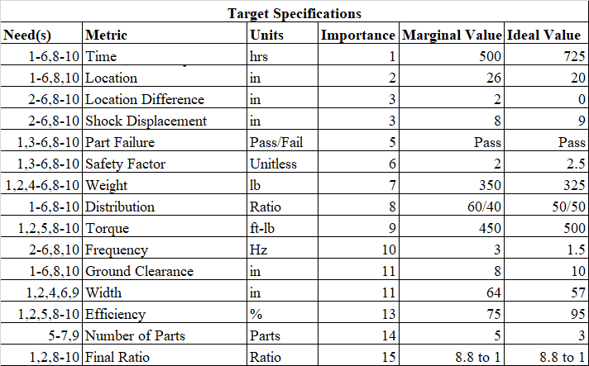

## **III. Rear Suspension Concept Generation and Selection**

After establishing the customer needs, engineering characteristics and target specifications, the Suspension team began to generate concepts. One method used was a morphological chart as shown in **Appendix C**. These were narrowed down to the top five concepts. These five concepts are the double A-arm, the trailing arm, the 4-link, the solid axle and the modified 3-link, or h-arm, suspension. Since each of these concepts were explained in detail in a previous report, they will not be included in this report. The next steps the team took were to down select through a screening matrix, pairwise matrix and selection matrix. The screening matrix compared the five concepts with the various customer needs to analyze which concepts fit the customer needs the best. The trailing arm and h-arm designs were ranked first and second as shown in **Appendix B**. Next, the team compared the target specifications against each other to determine the weight of each. The final step in downselection was a selection matrix. This matrix compared the weight of the target specifications to each of the five concepts. Through this down selection, the trailing arm and the h-arm were ranked in the top two again. However, in this case, the trailing arm was weighted more heavily. Upon inspection of **Appendix B**, the safety target specification heavily impacted the final result. As mentioned earlier in the report, VT Baja has run a trailing arm setup previously so the risk involved in this design is very low compared to the h-arm design.

After some preliminary analysis was performed, the team developed a Risk and Mitigation Plan (RAMP) to determine what issues the design might face and how the team intends to deal with these issues early. In doing so, the team determined the five failure modes which would impact our h-arm design the most and determined how we would act to reduce their effects. This entire plan is outlined in **Appendix D**. Two of the highest ranked risks found were failure of the half shaft due to impact during competition, i.e., rocks, railroad ties, etc., as well as half shaft failure due to back torque during jumps or other vehicle impacts. With the h-arm design, the half shaft would be the lowest member on the suspension, causing the shaft to receive more impacts than in previous years. The half shaft would also be a load bearing member in this design, causing failure due to back torque to have a catastrophic impact on the vehicle. While mitigation plans for both of these issues were determined, they caused concern for the team.

After determining these risks, the team discussed what options were available to move forward. From this discussion, the team decided to pursue an h-arm design with an added camber link. This design serves as an intermediate step between the trailing arm suspension which VT Baja has used historically and the pure h-arm design the team is looking to move toward. The camber link would carry the load, allowing the half shaft to not be a structural member. This reduces the risk of back torque failure greatly, as well as allows the camber link to be the lowest member and absorb the impacts from ground obstacles instead of the half shaft. This intermediate step allows the team to focus on the h-arm design this year, and allow next year’s team to focus on designing the complex half shaft to achieve the pure h-arm suspension system.

## **IV. Rear Suspension Early Analysis, Prototyping and Test Results**

One of the team’s goals for the year was to continue building a CarSim model of the vehicle to be used in simulations mimicking obstacles commonly seen at competitions. While most of the exterior dimensions were physically measured by the team, track width, wheelbase, etc., and entered into CarSim, the team was not able to obtain test data for the powertrain, most notably transient CVT RPM data, and suspension, such as bounce as a function of the vehicle’s position, so the default values were used in the CarSim model. In early November, the team performed a 100-foot acceleration test experimentally and virtually to evaluate the accuracy of the CarSim model with most of the default settings. The results are given in **Figure 1.**

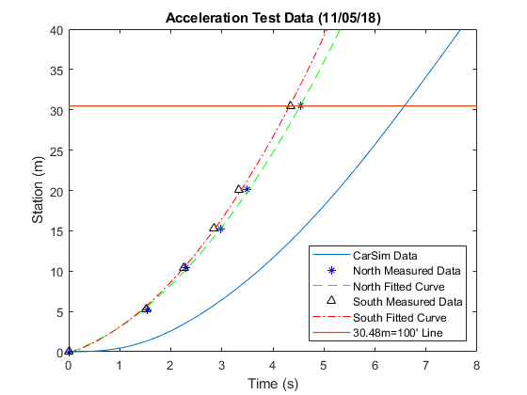

**Figure 1**. Raw data and fitted curves for the Acceleration Test.

In the Acceleration Test, the driver was instructed to hold the car at rest at the beginning of the track and give a full throttle when signaled. Timers stood at various intervals and recorded how long it took the car to pass their position. **Figure 1** includes 3 curves; the left two curves were obtained from performing the Acceleration Test in both directions along the track and the rightmost curve was generated from the exact same run in CarSim. This large error was a result of the CarSim powertrain model being inaccurate due to the lack of CVT data. Currently, CarSim’s powertrain model is being re-analyzed with the help of the CVT’s designer, who graduated last year. With modifications, the team was able to reduce the error to 31%. Although the error is still large, the team is not concerned about this because CarSim is primarily being used to aid in designing a new suspension.

Once the CarSim model was accurate within an acceptable error, the team began to conduct advanced Finite Element Analysis on components using ANSYS. This year, new standards are in place to ensure that simulation results are valid. The team has determined that all FEA will fit in one of three tiers, with each successive tier increasing in difficulty and computation time. The Easy tier FEA will be conducted for simple loading and simple geometry. These simulations will not drive design decisions. The medium tier FEA includes complex loading, some nonlinearities, and with known boundary conditions. The Hard tier FEA is reserved for extremely nonlinear problems of which we have no prior testing or validation. For the Hard tier, a realistic model is nearly impossible to develop with our resources, and we must find an alternate solution.

To corroborate the FEA results, the suspension team ran an instron test on a section of the h-arm. The shock tab joint was selected because the team ran into simulation errors within solidworks and observed failures in one of the tabs on a welded length. To confirm that the failure was a factor of simulation, as well as to verify the ansys model, the team loaded the test piece into the instron and recorded the displacement and the force. The results are included in **Table 2** below. As seen in the data, the 400 lbs load shows a percent error of 10.8% and the 984 lbs load shows a percent error of 6.1%. These results helped the team not only move forward with confidence in the tabs but also corroborate Ansys as a testing tool.

**Table 2.** The Instron Test Displacement Results compared to the Ansys Simulation Results

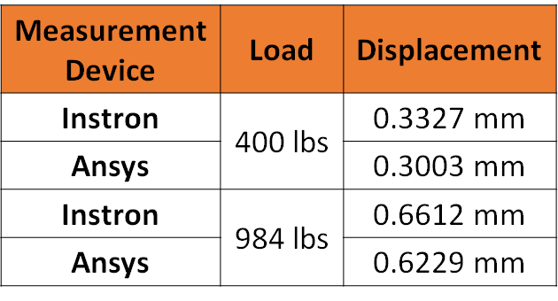

**V. Rear Suspension Design**

After downselecting to the h-arm and camber link suspension design, the team optimized the geometry and kinematics of the design. It is important to take note that the determined suspension design determines the three dimensional models, it does not determine the geometry and kinematics of the design. The final geometry and kinematics are included in **Table 3**. The kinematic design was driven by minimizing the camber and toe through travel. This allows for maximum contact between the ground and the tire to maximize the power applied to the ground.

**Table 3.** Final Geometry and Kinematics of the 2019 Suspension Design

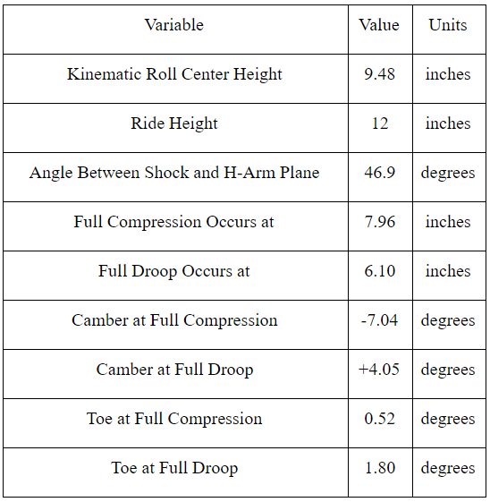

The kinematics and geometry, shown in **Appendix G**, were used to drive the quarter car models shown in **Figure 2**.

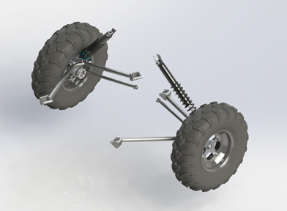

**Figure 2.** ¼ Car Model of the 2019 Rear Suspension

The h-arm model utilized another change in the suspension design. Instead of using tabs and bushings to mount the component to the chassis, this year’s design uses yokes and sleeved holes through the chassis. Originally, the yokes were machined 4130, as shown in **Figure 4**. However, the original design was difficult to manufacture so a sheet metal clevis, shown in **Figure 3**, was designed to ease manufacturing.

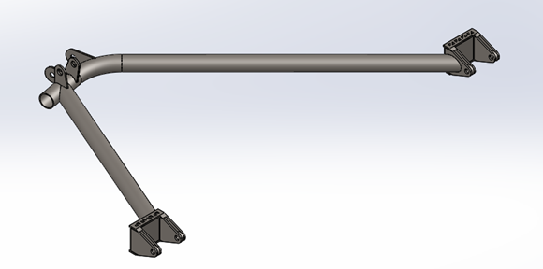

**Figure 3.** Iteration 2 of the H-Arm Model with folded sheet metal clevises

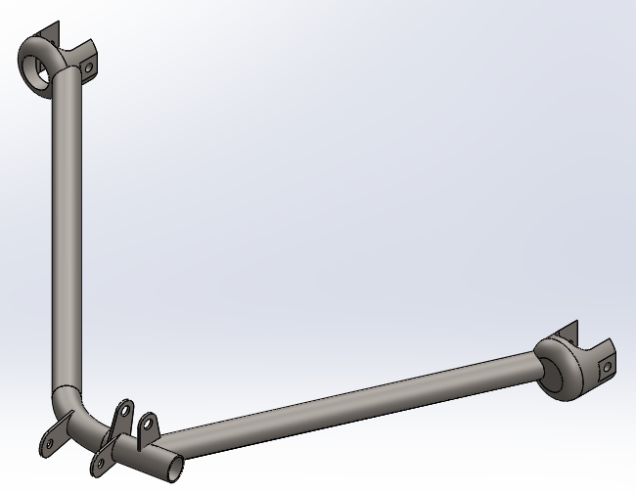

**Figure 4.** Iteration 1 of the H-Arm Model with machined clevises

The camber link design mimics previous years designs. As mentioned previously, this component was added to remove the structural loading from the driveshaft. It uses high misalignment heims to allow for maximum travel as well as adjustability in the toe of the vehicle.

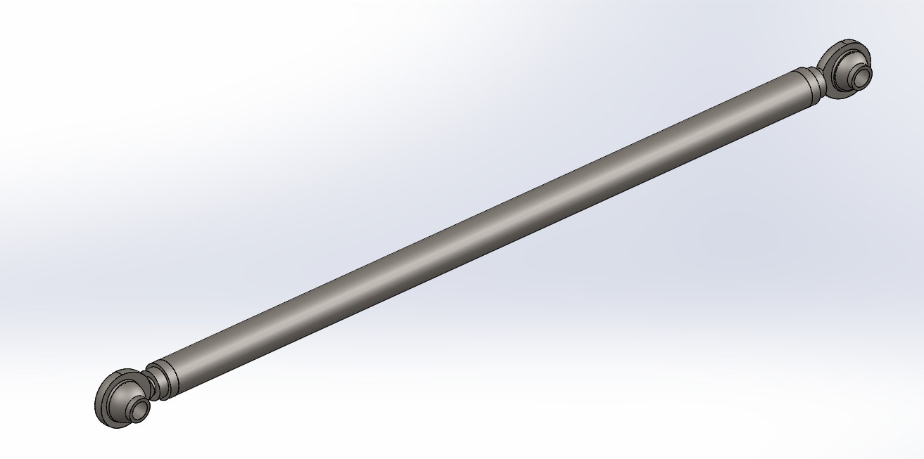

**Figure 5.** Camber Link Model

The bearing cup design is also a new component style for this year. Previous years’ trailing arm designs featured an integrated a steel bearing cup, welded to the sheet metal body of the arm. While a steel cup concept was generated this year, it was roughly twice as heavy as the pattern which was chosen, the left-hand side model shown in **Figure 6**. This year’s bearing cups are to be machined from Aluminum by a 3-axis CNC mill with an additional operation on a vertical mill to drill the pivot bolt hole. The camber link bolt hole is to be tapped and helicoil threaded for longevity. Weighing just over 0.6 lbs with both the working material of 7075 and alternative of 6061, these cups are considerably lighter than their steel counterpart, weighing over one pound. Internal dimensions are nearly identical to those used in previous years, and the same bearings which the team already has on-hand are to be used. An interference fit between the bearing’s outer surface and the cup’s inner surface retains the bearings in place in the cup once they have been pressed in hydraulically.

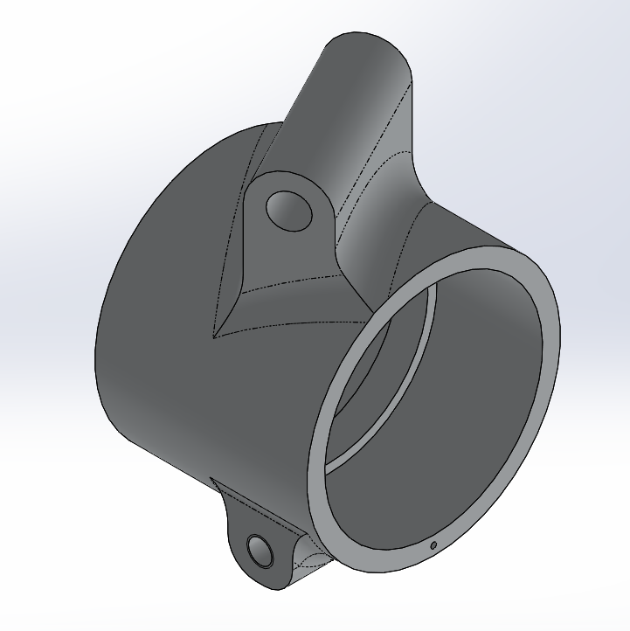

**Figure 6.** Bearing Cup Model

The rear hub design was carried over from previous years but integrated with the 2019 kinematics. Part of this integration was the offset on the column of the hub. This is to set the track width of the vehicle to assist in maintaining the camber characteristics. This geometry constraint lead to a higher factor of safety that will be discussed later on in the testing section of the report. Because of the high factor of safety, the hub was selected to test a new manufacturing method called MELDing. MELDing allows for a reduction in the waste material during the manufacturing process because the material is printed to a shape that more closely matches the part. **Figure 7** helps depict the difference between machining a billet versus the melded blank. Further MELDing information, including the stress strain curves and pictures of sample pieces, are included in **Appendix F**.

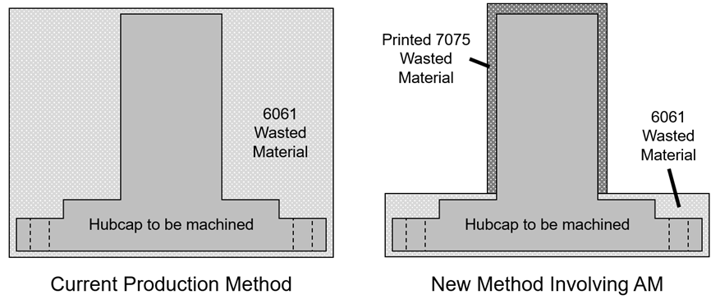

**Figure 7.** MELDing Waste Material Reduction

## **VI. Consideration of Multiple Factors in Suspension’s Design**

*Public Health, Safety and Welfare Factors*

The team’s product is an off-road race vehicle, which is maneuvered over logs, railroad ties, and jumps, as well as around tight turns at high speeds. With this, the safety of the driver and other drivers on the course is a huge factor in our design. Our target specifications include center of gravity location, CG location difference, and the safety factor of our design to keep the vehicle safe from rollover, part failure, and other potential safety issues. To expand on one of these issues, the part failure makes the creation and operation process focus more on the safety and reliability of the components the team designs. The customer needs require a minimum factor of safety for all design components to be 2. This will make sure that the vehicle is less likely to have a component failure.

*Global Factors*

The rear suspension utilizes steel in 75% of the subsystem. Up until recently steel was not difficult to acquire, however, steel is primarily imported from China. With the reliability on an external country, the team risks increasing costs, especially with the steel tariff increase. To avoid any complications imposed by trade restrictions (especially considering the current state of tariffs as it applies to the auto industry), the team could look to procure all imported materials domestically.

*Cultural Factors*

The team is constructing this vehicle for a highly publicized competition. The team can leverage this to create an educational platform for the general populace or for underserved students. There is a deficit of women in STEM across the globe, and Baja can highlight the activities of the women on the team to inspire younger women to pursue a similar career. Furthermore, the team can embark on outreach trips to local schools to teach children of all ages, races, and genders about the engineering design process. Because the competition is sanctioned by SAE (Society of Automotive Engineers), the team carries a strong reputation within the area. Team members should actively prioritize women and transparency in the engineering process so that the team can be more well-integrated. While designing and constructing the Baja vehicle is a massive undertaking by itself, the team should have an equal focus on bridging the existing cultural and gender gap in STEM to not only brighten the future of engineers in society but also to boost the diversity of the team.

*Social Factors*

A potential social factor that the team has to consider is that not all people will fit into the vehicle, or in other word, people may not feel comfortable at the current position. The team should consider design adjustable seat, brake paddle, and accelerator and so on to meet different people’s requirements. Another factor that applies to the driver is that the product, while assuredly built with top-of-the-line safety equipment, is still inherently a risk to operate. Any racing competitor is aware of the risks that accompany a racing vehicle. The team might wish to consider adding gauges or displays to the dashboard to monitor operation of the engine, differential, brakes, and other drivetrain components. This would ensure confidence in our customers that the vehicle is operating as designed and there are no critical failures.

*Environmental Factors*

The team this year is implementing a new suspension design, this means there are several complex parts. Components like the rear upright, rear hub and clevises require a lot of machining and therefore a lot of waste material. The team should look into ways to reduce the complexity of the parts by focusing on basic geometric shapes like circles, squares and triangles. The team cold also look into alternative, additive manufacturing for certain components to reduce the excess material. Beyond the excess material, the vehicle uses many fluids which cause environmental concerns, such as fuel, oil, brake fluid, and other fluids used in the manufacture and use of our project. To prevent leaks and other issues, our team follows the guidelines for storage and cleanup provided by the Ware Lab. However, these guidelines do not cover spills and other incidents at our test track or at competition. As such, we may need to create documentation for how to clean spills and other issues at outdoor events to maintain environmental safety.

*Economic Factors*

According to the SAE design series, we are design engineers creating a prototype vehicle to eventually be sold at 4000 units a year. This means that the manufacturing method for creating all of the components should be taken into consideration, and affects the final cost of the vehicle itself. This vehicle as a prototype costs about $17,000 to manufacture in house, but after bulk orders are taken into consideration it should cost no more than $10,000 even. For a high performance off-roading vehicle, this is a reasonable price to pay. The demand is estimated to be at or more than the production rate, and allows for potential resale values to be higher than the initial purchase price. This means the vehicle is more of a collector’s item, potentially sitting and appreciating in a person’s garage.

## **VII. Rear Suspension Test and Validation**

Due to the nature of the grueling competitions, each component on the vehicle must be proven and tested independently before being trusted to run on the vehicle. Each of the target specifications that are listed in **Table 1** must be tested using a validation plan. These plans ensure that the competition vehicle meets the initial design goals, and allows for a quantifiable measure of target specification compliance. As can be seen in **Figure 8** below, this is the first page of the suspension travel testing procedure. It allows for all of the sensors that are recording data to be tracked, and has a portion in the bottom right that allows the testing coordinator to sign off that the data is correct. This maintains accountability for those who are conducting the test, while tracking who has run what tests on the vehicle.

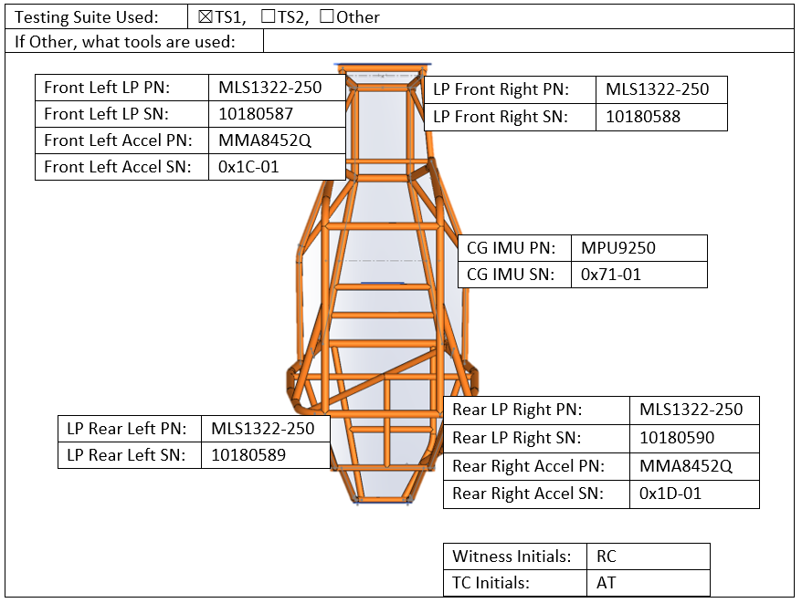

**Figure 8.** First page of validation plan for tracking SN/PN.

This test specifically allows checks for the standard shock displacement seen when driving the vehicle in an endurance event setting. The vehicle will be taken to the test track and run on the inner and outer loops. This allow for the compression of the shocks to be measured through standard banking turns at high speeds, tabletop transitions, bucking whoops, offset whoops, and railroad ties. The test will be completed five times taking a maximum of two minutes, and is to be completed without hesitation between obstacles and without driver or component error.

For the time target specification, there is not a direct test to determine component lifetimes due to budget restrictions. Each component was designed to survive for an entire competition season, which consists of testing, three Baja SAE competitions, and one Louisville Midnight Mayhem competition. With this in mind, a driving log for this year’s club vehicle was established, to determine how long the vehicle has been driven. The log also tracks who was driving, what obstacles the vehicle encountered, and any failures the vehicle experienced to keep track of how long components last. This target specification is currently being tracked.

Another requirement for the design was to minimize the number of main components in the design. With fewer components, the design will be optimized for ease of manufacture from previous designs. To test whether the design has met the target specification, each of the main components were listed and counted. In this design, there are three main suspension components: the H-arm, the camber link, and the upright. This meets the target specification of three main components, which is lower than the previous five component design.

Another requirement for the design is to achieve factor of safety for major components higher than 2. With higher factor of safety, the vehicle will be more likely survive the competitions. To test factor of safety, finite element analysis is applied to major components at their load cases. For the upright, 335 lbs torque was applied in y and z direction, and 1000 lbs sinusoidal bearing load in y direction, it had factor of safety of 6.2 and 4.6 respectively. For the hub, a 900 ft-lb torque was applied across the 4 bolt holes, it had factor of safety of 4.4. For H-arm, a 400 lbs compression load was applied, it had factor of safety of 2.2.

For validations of the center of gravity and mass of vehicle, the team calculated the total weight of the vehicle using 4 scales, one for each wheel. To summarize the center of gravity testing, the vehicle was placed on scales flat first, measurements were collected, then the rear was raised by 15.25 inches, or 10o (this was the limit before safety became a concern) and measurements were collected again. The measurements are included in **Figure 9**.

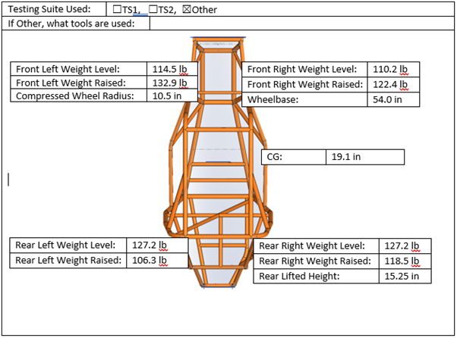

**Figure 9.** Resulting data used for calculation of the center of gravity.

The resulting data was then processed by the standardized equation:

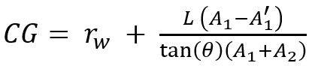 **(eqn. 1)**

Where rw is the wheel radius to include the height of the wheels, L is the wheelbase length, A1 is the total front weight when leveled, A1’ is the total front weight when raised, A2 is the total rear weight when level, and A2’ is the total rear weight when raised.

The CG is found to be at 19.1 ± 0.4 inches as a result. The uncertainty is based on the one result, collected, however since 2 of the scales were potentially off by 3 lb or less the result could fluctuate by up to 0.4 inches. The measured CG is right at the middle of the drivers hip and since the driver sits almost on the floor of the vehicle, it would be difficult to go any lower. Using similar procedures, the team was able to determine the weight distribution (rear/front) of the vehicle. This is done by simply by summing weights at the front tires and rear tires and listing them as a percentage of total weight. We marginally expected a 60/40 distribution. Ideally, we would have a 50/50 distribution. The validation test concluded that the actual distribution was 57/43.

Another design requirement is the ground clearance. This was done by visually inspecting the vehicle’s rear suspension to find the point that is closest to the ground (the lowest point on the suspension). This process was repeated three times on the same suspension component; the average ground clearance is 10.0”. This met the team’s ideal value exactly and surpassed the marginal value of 8”.

To measure the roll center location difference, the team first located the members that connect the wheel hub to the chassis. This is the A-Arm and control arms on the front suspension and the H-Arm and camber link on the rear suspension. A line was drawn through the center of the links until they intersected (the instantaneous center of rotation, ICR). Another line was drawn from the ICR to the middle of the opposing wheel’s contact patch. The roll center is the point on this line that intersects the center of the vehicle’s track width. The team measured this height from the ground, and repeated this process for both the front and rear roll centers. Finally, the two heights were subtracted, yielding the roll center difference. The roll center difference was measured to be 3”, which met the marginal value (3”) but not the ideal value (>3”).

To measure the track width, the car was first set at ride height. Then, using a tape measure, the distance between the center of the contact of the two rear tires was measured. This distance is our track width. Marginally, we expected to be at most 64 inches. Ideally, our track width would be 48 inches. The final value was 50 inches.

**VIII. Rear Suspension Project Team and Resource Allocation**

The Suspension team consists of eight members. All members report to the team facilitator, Katie Brown. Then the sub-team breaks into two groups: testing and designing. In the designing side of the team, Katie Brown and Andy Randell have taken ownership of the kinematics of the rear suspension. Their job is to design the geometry and kinematics of the suspension setup. Andy Randell and Rob Callaham are the two driveshaft designers. They are in charge of researching and designing the appropriate driveshafts for the suspension design. Finally, Aric Porter and Viktor Zorya have taken ownership of the hand calculations required to be confident in the design. Moving to the testing side of the team, Andrew Touzinsky is the hardware testing lead and is responsible for helping the team validate the designs. Jaisohn Kim is the CarSim lead and he is responsible for simulating the various designs through different terrains and corroborating the ANSYS FEA results and hand calculations. Bob Zhang has taken ownership of testing the suspension design through Adams. These results will help corroborate CarSim results. Finally, Joshua Clark is the ANSYS point of contact and his job is to run finite element analysis and corroborate the CarSim and hand calculations from the designers.

**IX. Skunkworks Introduction to the Design Problem**

Skunkworks is a newly developed sub-team of the 2019 Virginia Tech Baja SAE design team tasked with the improvement and advancement of vehicle systems. Following the “Design → Build → Implement → Test” cycle, we will design and construct a technologically advanced torque control system. A torque testing rig is used to verify design decisions, determined metrics, and integrate components of the sub-team’s validation and testing plan. Most importantly, the design will comply with the Baja SAE rules and regulations. Research will be collected and compiled transfer knowledge to future iterations of the Skunkworks team. Starting from basic principles of physics and vehicle dynamics fundamentals, the team determined our current design limits maximum lateral acceleration and tractive force; hence our concepts focused on solving these problems.

## **X. Skunkworks Customer Needs and Target Specifications**

There is more of a focus, as several past design have proven their success in the history of Virginia Tech Baja SAE, on creating an unique system to improve the team’s competitiveness. In discussions with the client, several important needs were portrayed. The client stressed that the system must comply with Baja SAE rules, and pass competition check tests such as the brake check test. If the system were to fail compliance with the Baja SAE rules or fail brake check test, the vehicle would be ineligible to compete in the dynamic events. Not complying with the Baja SAE rules and not competing in the dynamic event is a failure for the design team. Testing will ensure the safety, reliability and improvement of the vehicle’s performance. **Appendix I** includes the first and second section of the Skunkworks customer needs and engineering characteristics. The needs of the customer were directly related to the steps needed to win at competition. Winning at competition was further reduced to defining the needs to win individual events at competitions. These specifications have applied metrics with marginal and ideal values, as well as their linked customer needs. These metrics can be seen in **Table 4** below.

**Table 4.** Skunkworks Target Specifications with applied metrics

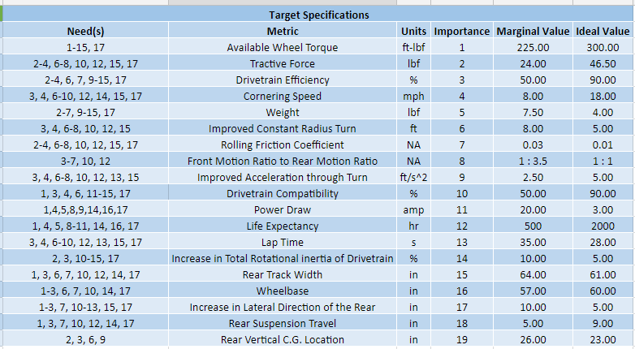

These marginal and idea values were compiled from testing and experience from the previous year’s competition vehicle. Several metrics, however, will need further verification through physical testing of the new vehicle. Many of these metrics were determined through analysis of past competition vehicles, including Virginia Tech and non-Virginia Tech vehicles. These aggressive metrics will allow the team to design and construct a well-rounded and efficient design, that largely outweighs the power draws from the system. Several of the target specifications involve the collaboration with the Rear Suspension Team, as the system will need to adapt to the kinematics of their system. In the combined use of customer needs, engineering characteristics, and target specifications, the team generated concepts to best satisfy the client’s needs.

**XI. Skunkworks Concept Generation and Selection**

After identifying the customer needs and target specifications, the team decided that a project focusing on the vehicle’s cornering capability was most appropriate. The team generated five concepts, found in **Appendix J**, to increase average cornering speed. The first concept was a torque vectoring eLSD, which utilizes 100% of torque from the engine at all times, unique from common LSD designs, to create an optimal torque split to the wheels that increases cornering speed. A set of linear actuators are used to engage/disengage two clutch packs (one for each drive wheel) to complete the torque splitting process. The linear actuators are controlled by an Electronic Control Unit (ECU) that works by using a closed loop (feedback loop included) response system with situational presets to continuously adjust the LSD and optimize tractive force. To ensure a robust system with quick and well-calculated responses, a variety of vehicle dynamic sensors is necessary. Furthermore, implementation requires a repositioning of the gearbox (a simple tilt along the input shaft to the gearbox) to accommodate the necessary mounting points of the eLSD.

The second generated concept was a Dual-CVT Powertrain. Theoretically, the design increases tractive force and cornering speed by continuously varying the gear the ratio at each drive wheel to stay within the engine’s peak performance interval. The design uses a CVT and gearbox at each drive wheel to individually control the torque being split to the two drivelines by the main gearbox. The use of two CVTs will optimize torque output, but it will increase the complexity of design and manufacturing, along with doubling the drivetrain weight. Furthermore, doubling the amount of moving parts in the drivetrain requires the engine have enough power for a substantial increase in rotational inertia, but the engine does not have enough power to make such a substantial change. The difficulty involved in tuning a single CVT is well known to the team with its experience tuning the current CVT; therefore, the team cannot justify such a difficult task with high risk of failure.

The third concept was a MagneLSD, which is a torque vectoring fluid coupling utilizing a unique magnetorheological (MR) fluid. The output shaft is connected to a turbine impeller that is encapsulated in a special housing that contains the MR fluid. Similar to a torque converter, another impeller, the secondary wheel, is driven by the moving fluid and outputs the transmitted torque to the driveline. This system is unique from a basic fluid coupling in that the fluid actively changes viscosity based on a magnetic field input; as the fluid viscosity changes, the transmitted torque changes accordingly. Ideally, the MR fluid viscosity would be controlled by a magnetic field created by a solenoid with an ECU controlled current input. The large range of dynamic responses possible from this system would make a complete driveline system, along with providing a torque multiplying affect useful for several events in competition. The nature of the fluid also implies that back-torque felt by the gearbox during jumps is eliminated, possibly allowing for a weight reduction in the gearbox design. It should be mentioned that the MR is expensive and the team has no experience with a fluid with such behavior.

The fourth concept was a basic Bolt-On LSD. Existing off-shelf LSD products would be integrated to the driveline to save the team a lot of design and manufacturing time, allowing for more model validation time. However, this LSD design cannot utilize 100% of the torque output during cornering, as each drive wheel’s LSD can only receive a maximum of 50% torque from the engine, resulting in a significant power loss at the wheels.

The last noted concept was a Regenerative Suspension System. Suspension travel and damping is controlled by an MR fluid with dynamic viscosity. The fully dynamic adjustability and fast response of regenerative suspension provides independent suspension control at each of the four wheels. Integration of an energy storage from the induced current in suspension travel is useful to support basic telemetry instrumented on the car. Instruments will be used to collect live vehicle data to develop a health monitoring system for crucial vehicle components.

The five concepts were then compiled into a Screening Matrix, found in **Appendix J**, which was used to identify the most practical solutions and down select which designs to continue researching and designing. Through the use of the Concept Screening Matrix, the Torque Vectoring eLSD and the MagneLSD where identified as the most promising projects. Continuing with the Down Selection Process, a Pairwise Comparison Matrix, shown in **Appendix J**, was used to compare the weighted customer needs. The weighted customer needs allow the concepts to be selected based on its ability to solve heavily-weighted problems.

Note the two most important customer needs, Compliance with Baja SAE Rules and the Ability to Pass Brake Check, are required for the vehicle to compete in the dynamic events at competition. Likewise, Vehicle Maneuverability is necessary to perform well in the dynamic events at competition. Durability is necessary not only for product longevity, put for the vehicle’s performance in the four-hour endurance event. Lastly, Increased Power-to-Ground is important for the vehicle’s dynamic performance and should be a focus of consideration during design. The combination of the Screening Matrix and Pairwise Comparison Chart resulted in the weighted scores for the two down selected concepts detailed in the Concept Scoring/Selection Matrix shown in **Appendix J**.

After considering the engineering design process, project management, and logistics associated with each down selected project, the Torque Vectoring eLSD was chosen. This decision was based mostly on the impracticality of developing complex fluid models associated with the MagneLSD. The team’s inexperience in such a deeply complex field was paired with an insufficient amount of literature to fill the teams knowledge gaps. Additionally, the MagneLSD project requires a great deal of time for model development and simulation, along with a capital demand well outside the abilities of the team to realistically fund. A project of this caliber requires more than the one year of design and manufacturing time available to the current team. Nevertheless, the MagneLSD project has been handed down to the team’s underclassmen to eventually undergo development and model validation testing. The team does not want to completely scrap this concept because of the design’s capabilities to greatly impact the vehicle’s overall performance.

After further down selecting the Torque Vectoring eLSD, the team created a Risk and Mitigation Plan (RAMP) to examine what issues the design might face and how the team intends to deal with these issues early. In doing so, the team determined the five failure modes that would impact the eLSD the most. The top five risks and mitigation plan for each risk are outlined in **Appendix K**. After determining these risks, the team decided to continue to pursue the Torque Vectoring eLSD. This decision was verified using CarSim to model the difference in powertrain designs. A constant radius procedure was developed and conducted using the proposed LSD configuration (Red Car) along with the current fixed differential (Blue Car) simultaneously [5].

## **XII. Skunkworks Analysis, Prototyping and Test Results**

**Clutch Pack Development**

The clutch pack forms the system that couples and decouples the torque output from the differential gearbox to the half-shafts that drive the wheels. The output shafts of the differential gearbox drive a primary rotating housing, which drives a set of discs with friction material on them, and are connected to a driven steel plate via four springs. This system is shown below in **Figure 10**.



**Figure 10.** The clutch pack sub-system

For efficient torque transfer from the driveline to the half-shafts, it is important that the clutch pack’s friction pairs are pressed together when the vehicle requires a “locked” differential, and allow for some slippage for reduced torque transfer. Additionally, it is important to note that the clutch pack is compressed in it’s “default” orientation to ensure that the vehicle can still run and the driveline continues to transfer torque in the case of a failure in the control or actuation system.

To have an even pressure applied to the friction pairs, four springs are used. Using a differential element approach, the clamping force required on the friction pairs can be determined. Considering a required torque transfer of 425 lb-ft (which is the maximum torque output possible through the existing driveline), and a compression length for each of the four installed springs, the friction coefficient required in the friction discs can be plotted as a function of the stiffness of the springs. This plot is shown below in **Figure 11**.

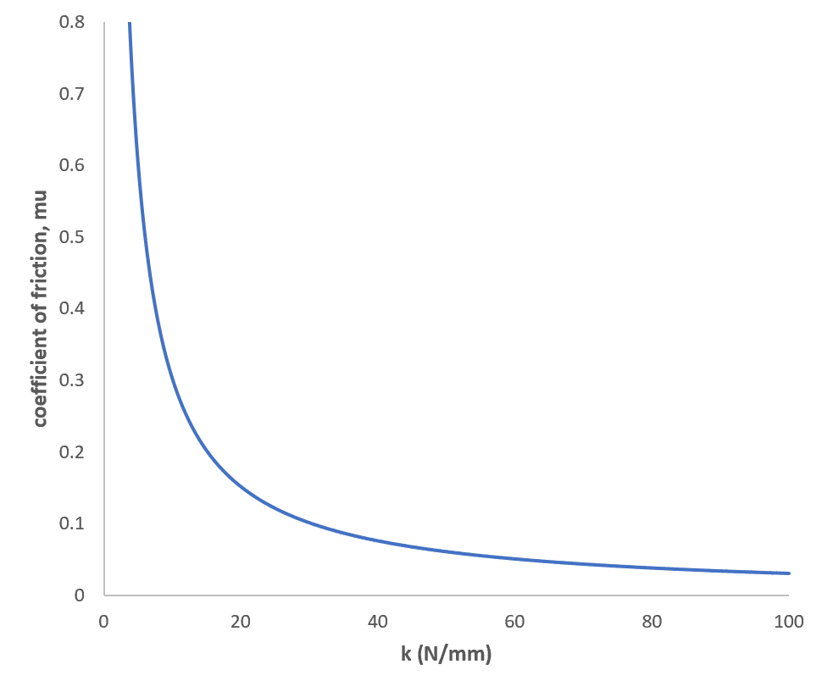

**Figure 11.** Required friction coefficient plotted against spring stiffness for a torque transfer of 425 lb-ft

From the plot shown above, the ideal spring stiffness range lies between 30 N/mm to 60 N/mm for a compression length of 20 mm. In this range, the torque transfer is largely independent of variation in friction coefficient, which may fluctuate with changes in temperature.

The clutch packs decided on are off-the-shelf friction discs with custom steel discs. The friction disc selection is important because the friction disc process is very complex. Therefore, the process cannot be done in-house. The team chose a friction disc similar to the ideal design, which lessens the complexity of machining while increasing the accessibility to the product.

The Torque Bias Ratio (TBR) determines the ratio of torque received by one wheel to the torque received by the other wheel. Therefore, the current fixed-differential drivetrain configuration would have a constant TBR of 1 because there is always 50% torque put out to each driven wheel. In the event of cornering, however, tire slip is inevitable due to the outside wheel traveling farther than the inside wheel. The TBR accounts for this in Equation 2 below, where R is the radius of curvature and T is the track width of the vehicle.

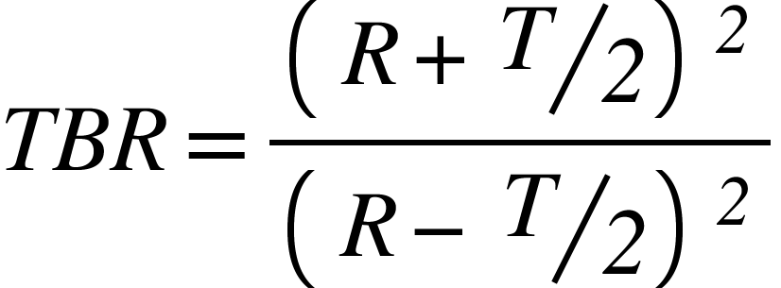

**(2)**

Considering a track width of 48 inches as in the 2018 vehicle, a performance curve can be obtained for a car travelling through turns of different radii. This is shown below in **Figure 12**.

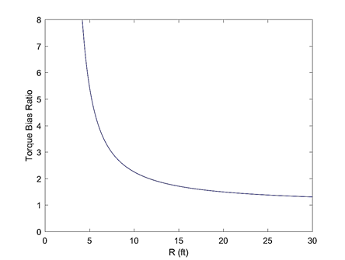

**Figure 12.** Relationship between Torque Bias Ratio and turning radius

The Torque Bias Ratio can then be used to determine the torque required at each wheel through a turn. For a given cornering speed, a drivetrain output torque, and a given turning radius, the torque split through the turn can be calculated. When implemented in a real system, a Torque Testing Rig or mule vehicle, the control unit will calculate the required torque values at every instant with changing output torque and turning radius. Considering a cornering speed of 16 mph and a reference output torque of 240 lb-ft, the torque required on each wheel with increasing turning radius is shown below.

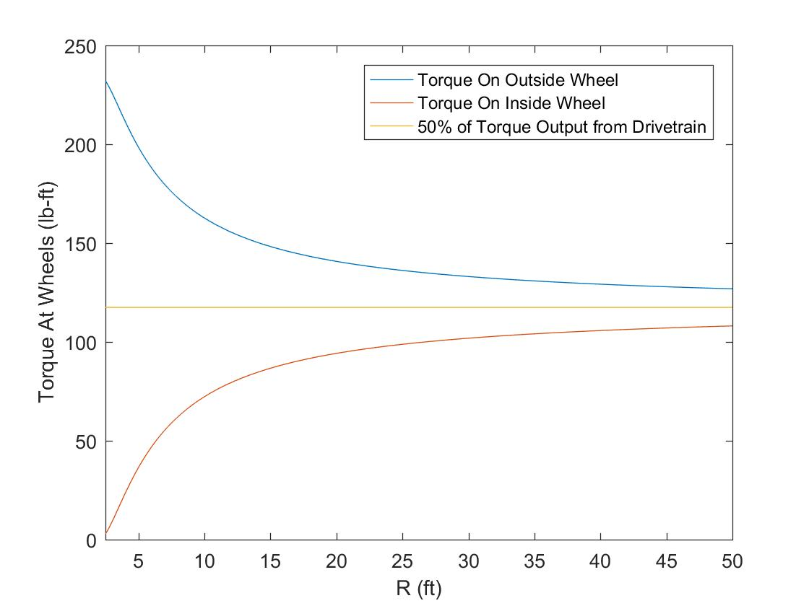

**Figure 13.** Torque split as a function of R for a cornering speed of 16 mph

The plot reiterates the potential gain in performance that can be achieved through efficient torque vectoring. The torque value used for these calculations is the torque required to cause a tangential acceleration of 5 ft/s2. However, once the CarSim model has been perfected and validated, the required torque split for a turn to achieve maximum performance will be obtained through CarSim, stored in the control system memory, and implemented (indirectly) through the differential system.

The required torque at each wheel is transferred using the clutch packs shown in **Figure 10**. Using the differential element method discussed previously, an expression for the required clamping forces for a given torque value can be obtained. Using the reference torque value of 240 lb-ft and driving conditions mentioned above, the clamping forces can be calculated for a given driving condition as a function of turning radius. This is shown below in **Figure 14**.

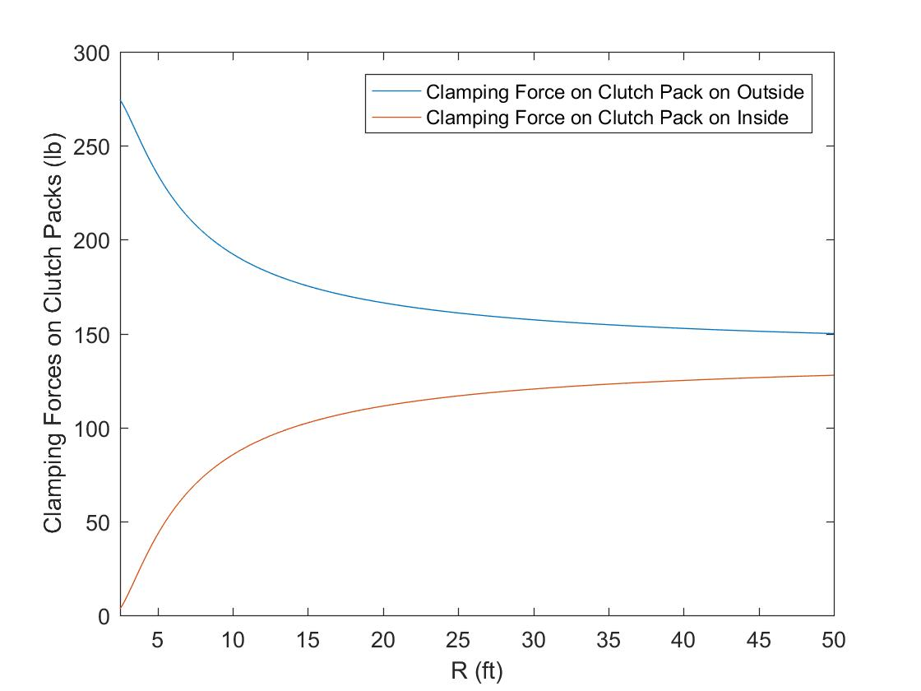

**Figure 14.** Clamping forces as a function of driving conditions and turning radius.

The control system will implement these clamping forces through a system of linear actuators. Keeping the need for a failsafe, to keep the car running in case of a control system failure, in consideration, the linear actuators will decompress the clutch pack, unloading the springs and therefore reducing the amount of torque being transferred to the half shafts. The control system will determine the required clamping force for a given driving condition, in the manner described in this section, and will control the linear actuators to provide the required clamping forces on each clutch pack.

**ECU Design**

An electronic control unit (ECU) will be used to actuate the clutches depending on the desired torque distribution. To find the necessary vehicle sensor instrumentation, the team worked backwards from the known desired output torque distribution, as shown in the progressive flow chart in **Appendix L**.

Next, the ECU hardware was finalized in corroboration with the Testing Team to begin electronic development, which can be found in **Appendix L**. A 6-axis IMU using I2C communication protocols was used along with the UART-based GPS module. In future ECU iterations, the GPS can be reconfigured to use I2C along with the IMU to reduce latency. Initially, the team aimed to utilize the dual core, shared memory, floating point co-processors, and other advanced features of the TI Delfino MCU because it was built for situations such as this, wherein one core can be used to collect and process the sensor data and the other can calculate and apply the desired torque split to the output shafts. However, the Arduino Mega was chosen for the initial ECU configuration due to Arduino’s extensive libraries and developer community. Once purchased, the components were wired to the Arduino as shown in **Figure 15** below. The software used for this wiring diagram is *Fritzing,* which is also the Testing Team’s software of choice for team-wide wiring documentation.

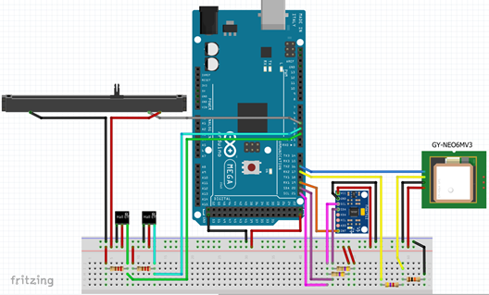

**Figure 15.** ECU Fritzing Wiring Diagram

The ECU software development is based on the Torque Bias Ratio (TBR), which determines the torque split based on the radius of a turn. **Figure 16** shows the high level software flow logic. The first step is to determine the radius of a turn depending on the speed of the vehicle; if it is above the defined threshold velocity, the yaw rate will be used, otherwise, the steering angle input will be used. Next, the radii to the inner and outer wheel is calculated using the track width and turning radius, following which the corresponding velocities and slip amounts can be determined. The state of the vehicle can then be found by analyzing the slip amount on each drive wheel. If both wheels have traction, apply the TBR directly, otherwise, increment or decrement the turn radius to compensate for some slipping of the wheels. In the case where both wheels are slipping, a sensor is malfunctioning, or any other potentially hazardous situation, the differential will lock as a failsafe.

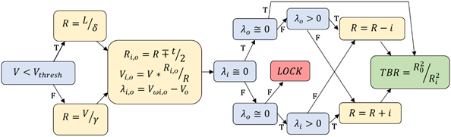

**Figure 16.** Software Flow Diagram detailing method of achieving desired Torque output.

An example ECU output from the Arduino displays the overall vehicle speed, left and right wheel speed, yaw/pitch/roll rates, and the output TBR [8]. Due to the project scope, the team was unable to implement the ECU and eLSD on a mule vehicle. Therefore, these values are purely proof-of-concept rather than that seen from testing data. Because the components were being manipulated by hand, the vehicle speed remains relatively low and the resulting TBR calculations yields a turn radius less than the track width, which is impractical, hence the common TBR of 1.00 which lock the differential.

Because this is a minimum 2-3 year project, future teams will focus on further system verification and validation as well as incremental hardware improvements, such as implementing the TI Delfino MCU, and software optimization.

**CarSim Prototyping**

As discussed in the Rear Suspension sub-team, CarSim is used to develop an accurate model for simulating the performance of the Baja vehicle. CarSim is a tool used for analyzing vehicle dynamics, developing active controllers, calculating a car’s performance characteristics, and engineering next-generation active safety systems. This software uses an efficient parametric math model to reproduce system-level vehicle dynamics behaviors under the control of a graphical user interface (GUI) intended for engineers to evaluate vehicle behavior.

CarSim was used in the concept selection process to verify the selection decision by conducting simulations that compare differing vehicle models. Using the “Washing Machine”, competition event, in addition to a full maneuverability track resembling that seen in competition, two different vehicles were tested simultaneously using the same driver model consisting of a path-following method and a constant target speed. The only difference is that one vehicle represents the 2018 powertrain design of a fixed differential while the other represents the proposed 2019 powertrain design of a custom yaw-control differential. The exact configuration of this differential, according to the CarSim Powertrain documentation page, is a “Yaw control differential system, which involves two clutches with reduction gears in parallel over a differential. The system allows control of the torque distribution between left and right” [4]. The comparison of a fixed and limited slip differential, shown in the CarSim simulation [6,7], allows for the support of the concept design selection. It was found that the yaw control differential improves on the fixed differential event completion time by approximately 20%, which is a significant improvement considering the brevity of the event. It is important to note, however, that the driving strategy utilized in the simulation does not represent what is expected at competitions, as drivers learn to utilize their vehicle by powersliding around corners. This does show, however, a clear advantage of using a torque-vectoring eLSD in opposition to the current design.

**XIII. Skunkworks Design**

After down selecting the concepts to the Torque-Vectoring eLSD, the team designed the system to implement a gearset. The initial thought of the gearset was that maximum torque would be distributed. Although this could be the case, the ideal ratio between the output gear shaft and the final drive would be 1:1, requiring a large gearset and therefore a significant amount of material. Furthermore, the design would require a sealable gearcase, filled with fluid. This would increase the weight of the eLSD, as well as increase the cost of the system. Therefore, the design was changed to a sprocket chain drive, allowing for a cheaper option that still delivers the required torque to the final drive. The sprocket chain drive does not require a sealable case, as the chain will be lubricated prior to running the system.

The use of sprockets will allow for a cheaper option for the team. In addition, the use of a sprocket adequately distributes the torque across about half the teeth on the sprockets, rather than approximately 1.5 teeth on the gearset. This change will allow for less stress in the components, which will allow for a thinner material. Chain drives require a tensioner, due to the stretching in the chain after running the system. The secondary sprocket, also known as the output sprocket, will have the differential housing mounted to it. The differential housing will contain the spider gears, side gears, and connecting rod. This housing can be seen in **Figure 17** below.

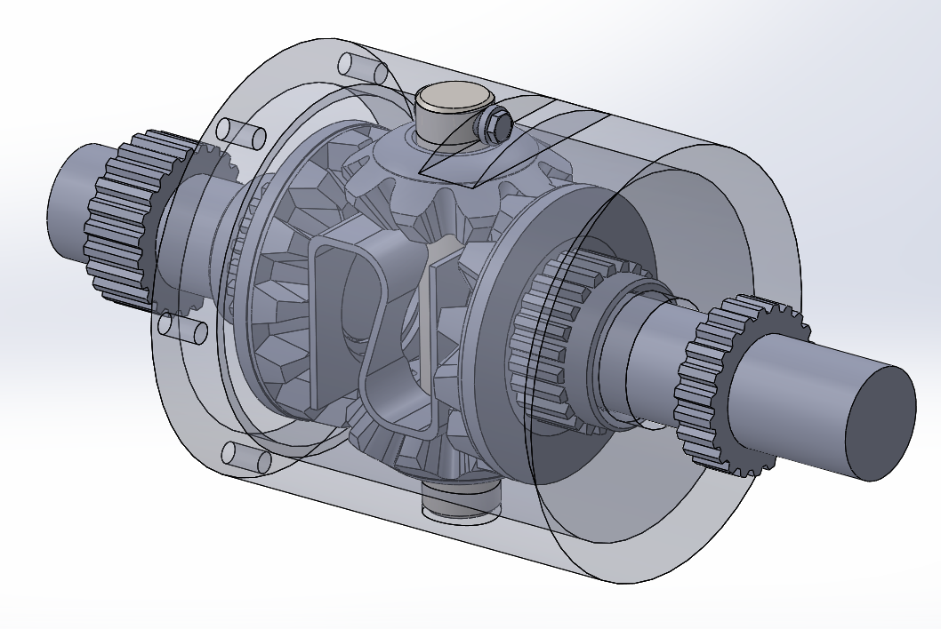

**Figure 17.** Differential Housing with Spider and Side Gears

The entirety of the eLSD consists of many components, which include shafts, sprockets, chain, gears, and clutch packs. Three shafts are required for the eLSD to operate correctly. The first shaft is the input shaft of the eLSD, which interfaces with the output shaft of the gearbox. The other two shafts interface with the side gears of the differential, which distribute torque to the wheels. The connecting rod connects the spider gears to the housing, which delivers power from the secondary sprocket to the final drive. The two sprockets deliver torque, at a 1:1 ratio from the gearbox to the final drive of the Baja vehicle. The chain connects the two sprockets together. The bevel gears assist in the driving of the wheels, as well as the vectoring of torque throughout turns. The final assembly of the eLSD can be seen in **Figure 18** below.

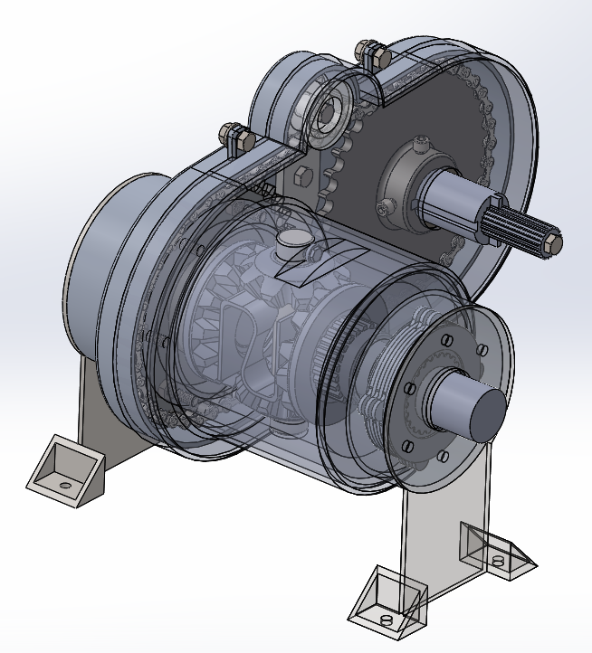

**Figure 18.** Complete Assembly of eLSD with Clutch Packs and Mounts.

The chain drive system refers to the sprockets, chain, the input shaft, and housing for the entirety of the system. The housing of the system does not need to be sealable, due to the lubrication method of the chain. Therefore, the casing needs to shield the chain from the elements. Roller chain, the chosen type for the chain drive, is greatly affected by contaminants. When introducing contaminants, including dirt, rocks, and water, the chain links will skip on the sprocket, causing damage and potential failures. The sprockets feature a 1:1 ratio, which can be changed with ease. Due to the power draw with the alternator, there can be a slight decrease in power when running the eLSD. Therefore, the ratio can be adjusted to counteract this power draw. The shaft associated with the chain drive system is the input shaft, which interacts with the output shaft of the gearbox. The input shaft interfaces with the primary sprocket, which connects to the secondary sprocket with use of a #40 ANSI roller chain. This size chain fits the custom sprockets, which allows for an appropriate factor of safety for preliminary designs. The chain drive system can be seen in **Figure 19** below.

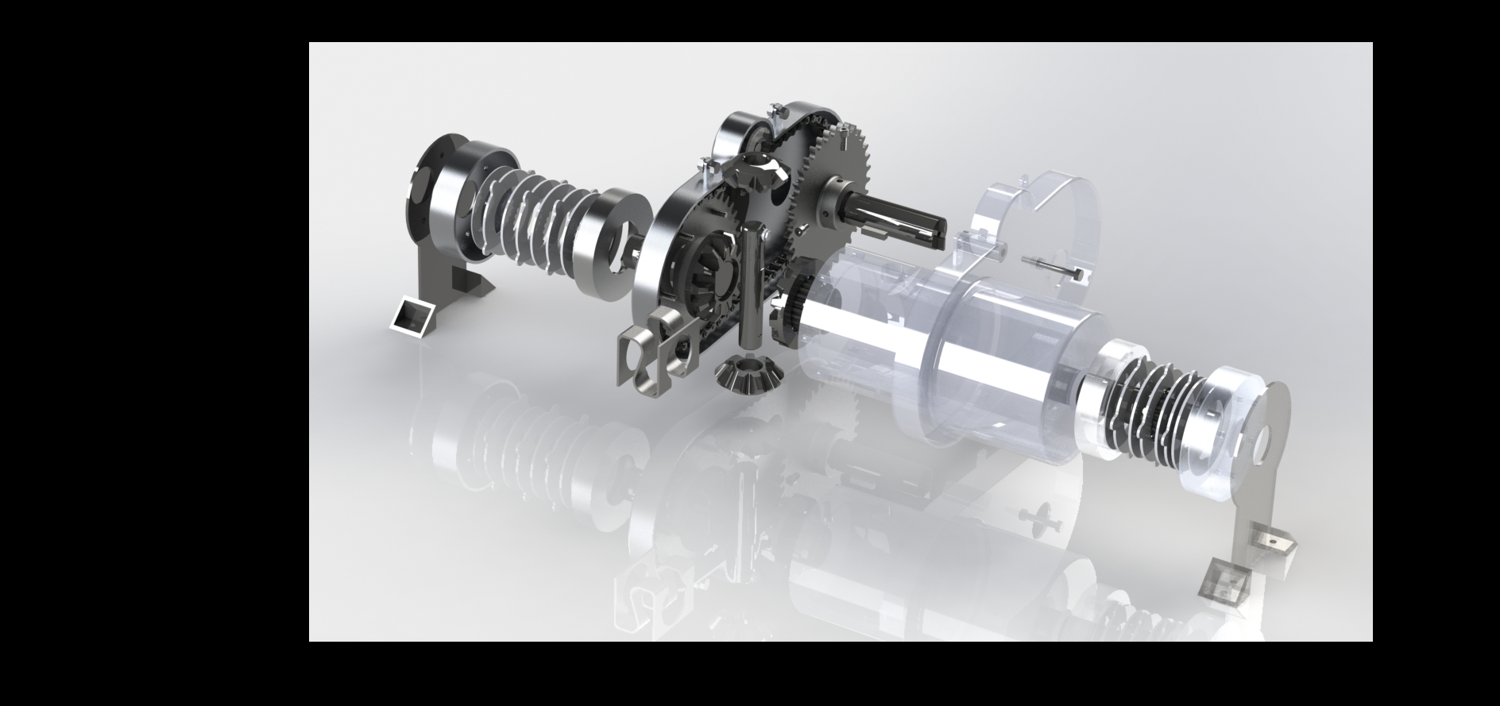

**Figure 19.** Full Exploded View of the eLSD

The eLSD assembly also features a clutch pack assembly that guards the clutch pack interiors. The assembly features a primary and secondary housing. The primary housing interacts with the clutch discs and steel discs, while the secondary housing shields and protects the clutch packs from the external environment. The differential housing connects directly to the output sprocket with hardware, to ensure that the differential works properly to the traditional operation. Furthermore, the differential features an overarching shield, to protect the driver and spectators in case of a failure.

The differential assembly refers to the differential housing, side gears, spider gears, output shafts, and half shaft interfaces. The spider gears are fixed to the differential housing with the use of the connecting rod. The side gears are used to output the torque to the wheels, as well as vector this torque through the turns. The vectoring of torque is important to the eLSD, as the Baja vehicle will increase overall cornering speed and acceleration through a turn with this concept. The half shaft interfaces allow for the final drive to connect to the outside wheels via the half shafts.   
 The driven housing (also referred to as the primary housing) is driven by the differential gear-sets. Since the primary concern is to transfer torque from the housing to the friction discs instead of the other way round, and since the torque input is relatively low because of the engine constraints, it was determined that the friction discs in the clutch pack will receive the torque through meshing teeth with the housing, as shown below.

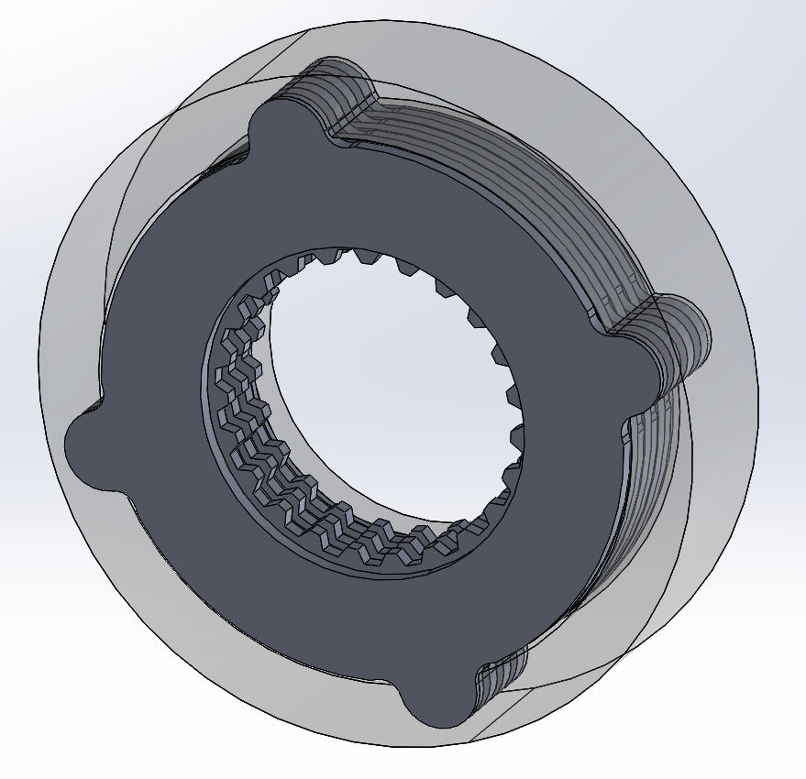

**Figure 20.** Meshed teeth of the friction discs (grey) and the housing (transparent) to transfer torque.

Since the temperature cases seen during operation are unknown, the ideal material for the friction discs is aluminium. Aluminium has a high thermal conductivity and is the best low-cost material that can be used in high-temperature applications. Additionally, the thermal conductivity of aluminium is around four times that of steel, and therefore it is more likely that a lumped capacitance assumption for the friction discs is more likely to be valid if the friction discs are made of aluminium. Hence, it is imperative that the loads seen at the meshing teeth of these friction discs are distributed well and evenly so that the load cases do not dictate the choice of the material.

To model the temperature change in the clutch packs, a thermal circuit was developed. The assumption was made that the heat generation is split uniformly across the three friction pairs, and occurs only in the friction elements. Then, using contact resistance values for aluminum-aluminum and aluminum-air interfaces at high temperatures, a thermal circuit was developed in LTSpice. This is shown in **Figure 21.**

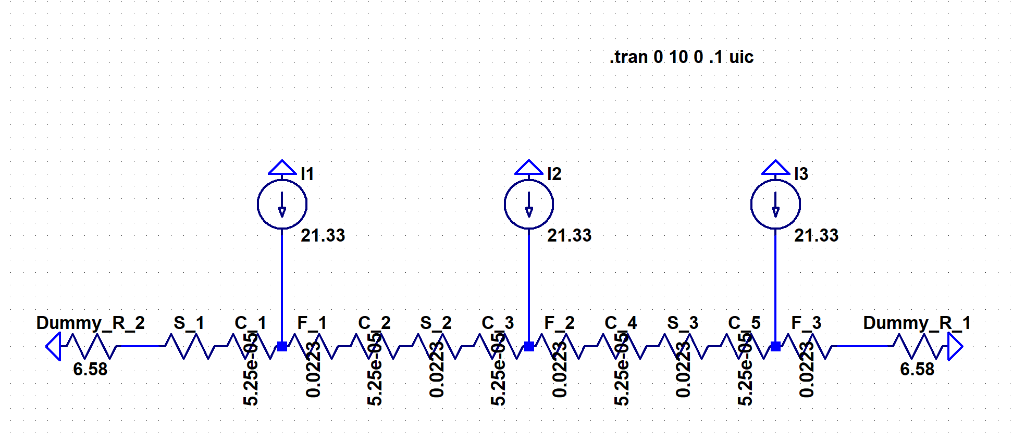

**Figure 21.** Thermal Circuit developed in LTSpice

Assuming that all the power lost under low slip (<10%) conditions is converted into heat energy, the thermal circuit analysis was done for slip percentages ranging from 1% to 10%. A summary of the results is shown in **Table 5.** Once verified through testing, this implies that the use of a lumped capacitance model is valid - because of the low temperature gradient - which allows the team to further optimize the design to have greater surface area for heat convection, without causing the initial mathematical model to lose validity.

**Table 5.** The Slip Percentages of the Clutch Packs compared to the Temperature Change

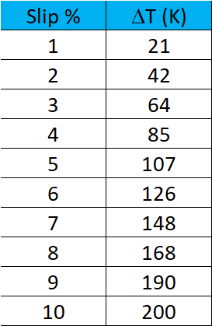

Since a lot of the parts in the secondary drivetrain are parts bought off the shelf for higher power applications, the Factors of Safety for these parts were extremely high, ranging from around 26 to 30. Therefore, the team decided to focus on reducing the rotational inertia through cutouts in the sprockets for better transient response.

The loads on the sprockets are shown in **Figure 22** below. This represents the absolute maximum torque load the drivetrain is likely to see, driven by an engine operating at peak capacity.

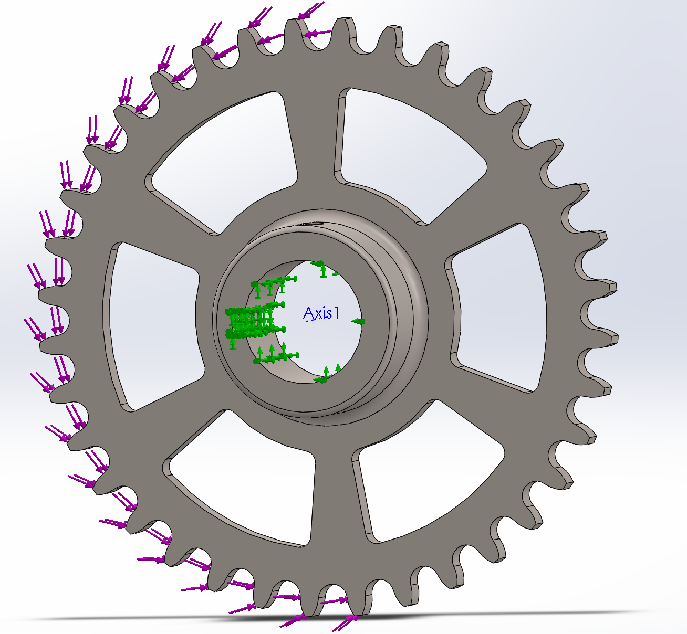

**Figure 22.** Loads applied to the Sprocket

The analysis showed that the sprockets did not lose structural integrity and should comfortably survive any shock loads (FoS - 2.7), **Figure 23**. Through the cutouts, the rotational inertia was brought down by a significant 29% over the initial value.

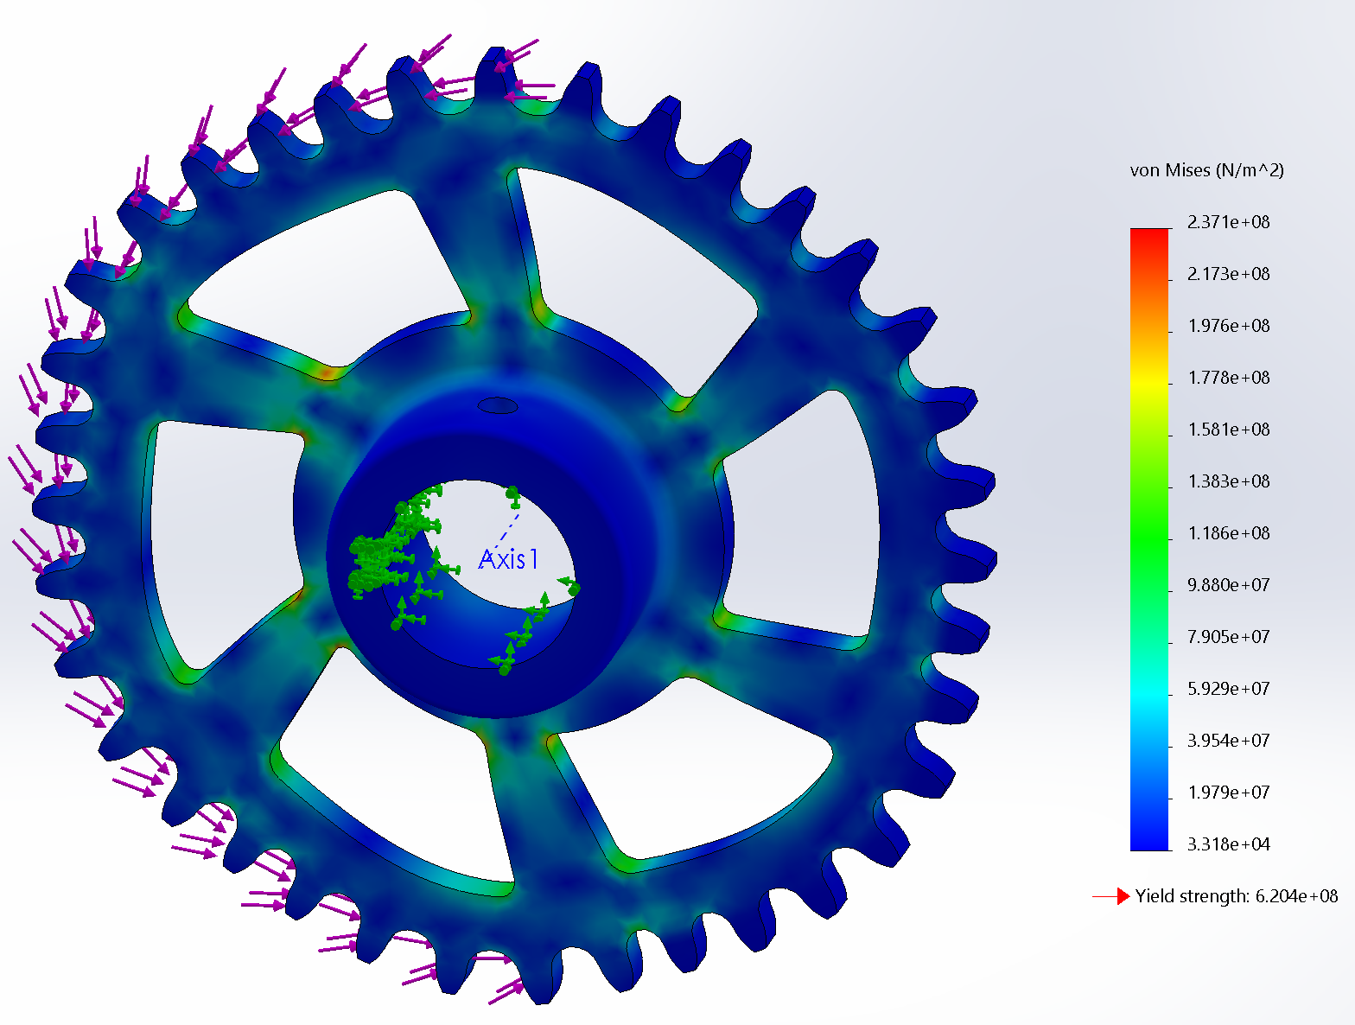

**Figure 23.** FEA Results on the Sprocket after reducing the rotational mass

The final design for the clutch pack housing showed a Factor of Safety of 1.4 under maximum shock load. In the overall analysis, this is the lowest value across all components. This has been intentionally done to have the housing serve as a mechanical fuse, where if there is to be failure, the clutch discs will cause the inner face of the housing to yield in, causing the friction pairs to get “stuck” and be left unable to actuate. This ensures sustained operation of the vehicle and eLSD even after seeing an unexpected load, and protects the more valuable components, like the linear actuators, from damage caused by the aforementioned loads. The figure below shows the faces over which the loads are distributed when the friction pairs are fully engaged and drivetrain is transmitting the torque developed as described above.

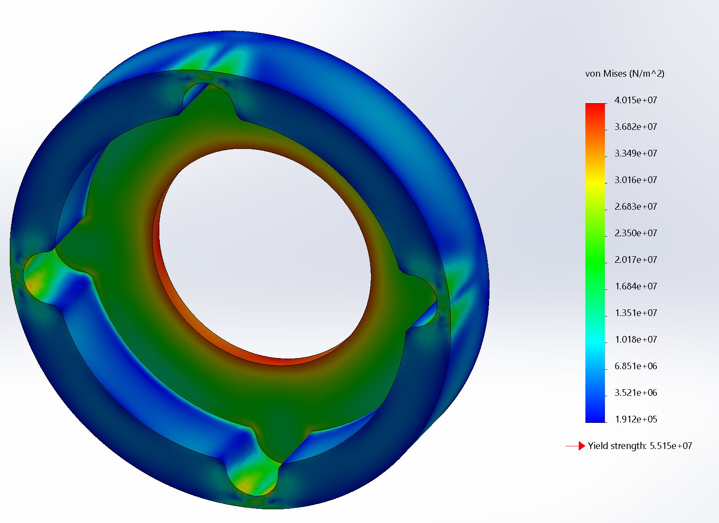

**Figure 24.** Clutch Pack Housing FEA Results

The final clutch pack design can be connected to the output of the bevel gear drive, and is shown in **Figure 25** below. The housing and the friction discs are made of aluminum.

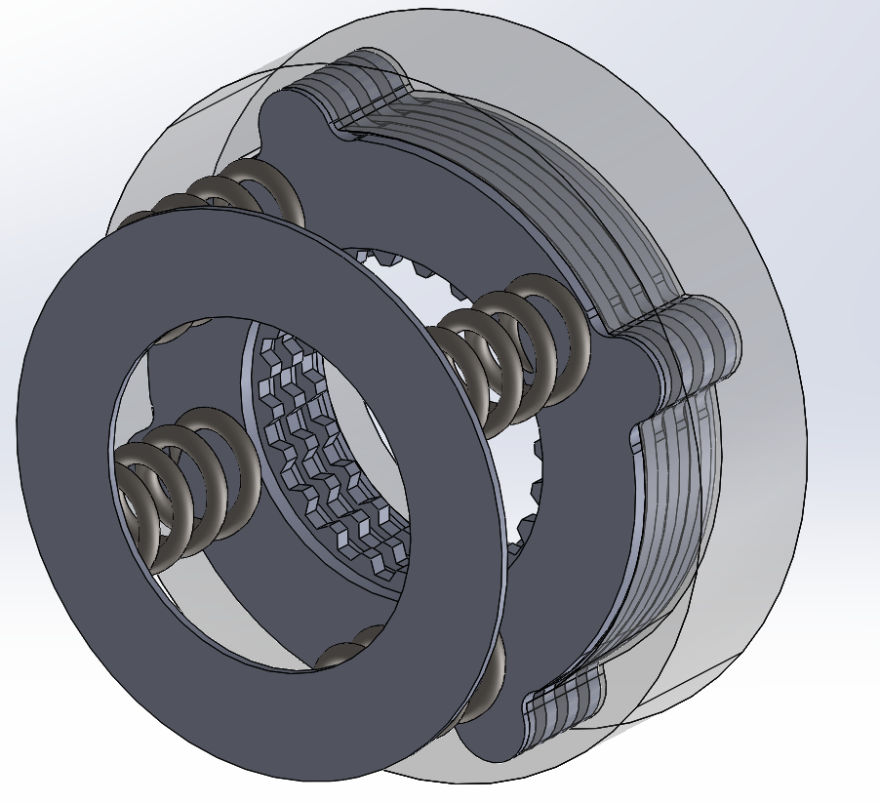

**Figure 25.** Final Clutch Pack CAD Design.

**XIV. Consideration of Multiple Factors in Skunkworks Design**

*Public, Health, Safety, and Welfare Factors*

Considering the competitive nature of the SAE Baja competition, safety of team members and team drivers is in constant consideration during the entire product development process. The team took safety into consideration primarily by developing the Torque Testing Rig for the eLSD. Such a new R&D project requires sufficient testing be conducted prior to the component’s installation on the vehicle. The Torque Testing Rig allows for the manipulation and demonstration of eLSD operation, without altering the competition vehicle. This device eliminates the associated risks of an underdeveloped eLSD, especially those resulting in harm to the driver. Furthermore, the torque testing rig has an encompassing shield that protects testers from fatigued part projectiles. The Torque Testing Rig features a remote Kill-Switch allowing operators to end a test at a safe distance in the event of a failure.

After integrating the eLSD into the vehicle, the driver could faces some risks during operation. In the case of a component failure, the eLSD may cause the vehicle to experience one or many of an array of unpredictable responses from the eLSD resulting in a crash. In some cases an eLSD component failure could seize the vehicle’s motion completely costing the team valuable time and competition points. In attempt to avoid the scenarios putting the driver in danger, the team specifically designed the clutch pack to allow the vehicle to continue moving without full function of the eLSD. The clutch pack was designed to stay in compression (unless actuated) continuously passing power from the drivetrain to the wheels. In the event of a component failure, the pre-compressed clutch pack allows the system to act as an open differential and continue competing or quickly return to the pits. It should also be noted that the system is designed for removal with ease. In the case of a broken eLSD, the team wanted to ensure the broken component would not compromise the vehicle’s ability to compete.

*Global Factors*

The SAE Baja competition has a large set of rules each team must abide by to legally compete in the competition. During all design and manufacturing processes, these rules are fully considered to ensure the VT Baja team can legally compete. Most of the legal factors that go into the eLSD link with safety. If the eLSD were to fail, the driver needs safely return the vehicle to the pit for evaluation and repair. Note transportation of the vehicle, supplies, and team members integrates full consideration of traffic laws across all of America. Specifically, the VT Baja trailer is road-legal and registered in Virginia. Lastly, it should be mentioned raw material supply is based in the U.S., hence there is no legal issues obtaining parts from other countries.

*Cultural Factors*

In view of SAE Baja culture, Virginia Tech will be the first team to use an electronically actuated Limited Slip Differential during competition. The eLSD is another step to move the culture of Baja from strictly mechanical designs (such as the traditional Continuously Variable Transmission featuring springs and flyweights used to roughly estimate proper shifting) to a more innovative approach utilizing precise electronic actuators. The eLSD will forge a new path to continue improving Baja vehicle performance.

*Social Factors*

The team decided to place illuminating buttons on the steering wheel, as well as an LCD screen for the driver. The light-up-buttons will indicate the current terrain setting of the eLSD—mud, dirt, gravel, ect. The LCD screen will be the primary source of communication to the driver. If a sensor reading or eLSD component fails/misreads, the LCD screen will display to the driver, flashing one second on and one second off for 5 seconds, that the eLSD is failing. The LCD will also display the failure point and the change in system operation to act as a locked differential. Said system keeps the driver informed to make a decision to stop in the pit and conduct an evaluation of the eLSD.

*Environmental Factors*

Due to the nature of the eLSD design, the friction plates in the clutch packs are the only parts that require regular replacement. The current plates will be recycled upon purchasing of replacements. The majority of eLSD components being metal, said parts can be recycled and then repurchased from the supplier for replacement when necessary. Note that any parts that are replaced but are not useless from wear will be used in prototype systems when perfecting the design in future years. Rather than machining bevel gears in-house, using cutting fluid, and creating waste material, the bevel gears were obtained out-of-house. Furthermore, the current bevel gear set was casted to keep waste to a minimum in a process outside of the team’s capabilities. The clutch pack design features a 1.3 FoS, which has the thinnest appropriate width on the edge of the housing, to minimize stock size needed. Opposed to machining the housing out of aluminum, causing a massive amount of waste, the housing was fabricated from sheet metal with small aluminum plates used to press in bearings.

*Economic Factors*

Economic factors were investigated during each step of the product development process to ensure a frugal use of the team’s budget. The eLSD concept was selected for design (as opposed to the standard LSD featuring spur and worm gears) to further the actuation accuracy and longevity of the product life. The eLSD costs approximately the same as a traditional LSD yet has several major advantages. The dynamic nature of the eLSD includes its ability to change clutch pack friction characteristics and torque transfer, as well as locking the differential on command. In some instances, a locked differential is more useful than a LSD, especially in a tight J-hook turn when the driver needs full control over the vehicle.

Furthermore, the ECU allows for constant improvements in the logic, as well as additions to the construction. The large platform of the ECU allows for continued performance customizing, future vehicle status output readings (such as Gearbox Temperature, Engine RPM, Suspension Travel, and Vehicle Speed) and dynamic behavior.

**XV. Skunkworks Test and Validation**

As there was not enough time for rigorous testing and validation of the vehicle in previous years, Skunkworks is allocating a sufficient amount of time for their robust testing and validation plan. A lack of testing was able to pass in previous years since vehicle designs were similar, however Skunkworks main goal is to ensure the safety of the new component before placing it onto the vehicle. Skunkworks has created a two-step validation plan. The first step of the plan includes validation with two tools, CarSim and a torque testing rig (TTR). The TTR is a custom machine that mimics the performance of the eLSD as if it were placed on the vehicle. The use of CarSim and the TTR allows the team to have both a physical and mathematical model to maximize the performance of the eLSD. Also, several target specifications need a physical testing method. The results from CarSim and the TTR will be used as a baseline for what is expected when the target specifications are validated on the vehicle. The goal is to correctly match the CarSim model to the output from the TTR. When the mathematical model matches the physical model, the team will be confident to test the component on the vehicle. Validating the components on the vehicle is the second part in the groups validation plan.

The group has created a validation plan which, listed in **Appendix M**. The validation plan lists the method used to validate each target specification. Each validation method gives a detailed explanation, including measurement device, step-by-step procedure, data collection, and safety precautions, to ensure the target specification is tested thoroughly.

For validation and testing results, see **Appendix O**. Using **Equation 3** below, the available wheel torque was determined.

$Available Wheel Torque = Engine Torque * CVT Ratio*Gearbox Ratio$ (3)

Plugging in values, we get: $Available Wheel Torque = 14.5 ft - lbf*3.0*8.8 ≡380 ft-lbf$

With the available ratios, 380 ft-lbf is the maximum available torque. Further interpolation with Hall Effect Sensors and car testing to determine the wheel to ground torque output for each wheel.

CarSim was used as a relative comparison validation and testing method for the following target specifications: tractive force, cornering speed, improved constant radius turn, improved acceleration through turn, and lap time. All of these metrics use two vehicle models, one of which represents the 2019 proposed vehicle implementing an eLSD and the other representing the 2018 vehicle with the fixed differential configuration. First, the tractive force and lap time metrics use the same track, which is representative of a maneuverability track seen at competition, the results of which can be seen in **Appendix O**.

The tractive force plot represents the longitudinal forces acting on the left (red) and right (blue) tires. The maximum force reached was 45.4 lbf, which successfully surpassed the marginal value of 24 lbf and is close to the ideal value of 46.5 lbf. The lap time, which can be seen in the the linked video, resulted in the blue vehicle finishing the track in about 34 seconds, which housed a differential, whereas the yellow car finished the track in about 38 seconds, represents a fixed gearbox. Based on this simulation, the limited slip differential has over a 10% improvement over the fixed differential.

CarSim was used to compare maximum cornering speed of the two vehicle configurations. Both vehicles are attempting to maneuver a radius of 12 ft using a full throttle driver control model. It was determined, as shown in the plot below, that the differential reaches up to 13.4 mph. This model relates to a turn at a competition track, at which this data can be corroborated. Similarly, minimum turning radius plot in **Appendix O** displays the position of the vehicle around an incrementally decreasing radius track at a constant driver control model of 10 mph. The model failed at the end of the 2.25 m radius, which equates to approximately 7.4 ft. The improved acceleration through turn was determined in the same way using a constant 12 ft radius and a full-throttle driver control. The model reached an acceleration of 4 ft/s^2, as shown in **Appendix O**. This value successfully surpassed the marginal value of 2.5 ft/s^2 but did not quite reach the ideal value of 5 ft/s^2. Further improvements can be made with implemented actuators. Hall effect sensor and GPS data will be used to determine the speed through a turn, which can additionally be used to determine acceleration.

The TTR was used to address the Drivetrain Efficiency target specifications by mounting a motor, aluminum discs, and hall effect sensors. Through the Testing team, a DAQ and other data processing tools such as MATLAB are currently being used. Further improvements, such as Friction Modifier in the Differential, can be used to increase efficiency.

The target specification of weight pertains to the addition of stock bevel gears and a 1:1 sprocket ratio rather than integrating into the output gear of the gearbox. Weight can be further decreased by eliminating unnecessary weight in the output shafts of the differential.

The rolling friction coefficient is currently tracking. One of the requirements for finding the rolling friction coefficient is to have our eLSD mounted to the vehicle, which has not been done. Once the mechanical and electrical components are properly tested, the eLSD can be mounted to conduct this test. Similarly, the front motion to rear motion ratio target specification is still tracking, as data is still to be received.

Using **Equation 4** below, the drivetrain compatibility can be determined based on the main components that would need to be redesigned.

$Compatibility \%=\frac{\#Parts in 2018 Driveline - \#Parts that need to be redesigned for 2019 eLSD}{(\#Parts in 2019 Driveline, excluding eLSD}$ (4)

It was determined that the team would only need to redesign the driveshafts due to the increase in lateral direction of the rear. The driveshafts would need to be shortened to accommodate the eLSD.

Power draw is based on following the rules from Baja SAE. The components do not have to be directly run from the alternator, A battery can be used to support the load while an alternator can be used to trickle charge the battery. The team received a value of 2 amps, which surpasses even the ideal value of 3 amps.

The life expectancy matrix is still tracking because parts have not reached failure at this point, so the hours will initially be tracked on the TTR. After Action Reports and diagnosing of any issues will be documented and filed. All shields allow for rotating components to be protected in the event of failure.

The increase in total rotational inertia of the drivetrain was measured using theoretical calculation and back-torque testing. The 2018 drivetrain is bolted onto the TTR, returning approximately a 163% increase in inertia. This is largely caused to the addition of a whole secondary drivetrain, which was not expected in the creation of these target specifications. Future designs may incorporate torque vectoring elements in the gearbox, reducing number of rotating elements and rotational mass.

Using a tape measure or caliper, the increase in lateral direction of the rear was determined to be 6.54 in, which is between the marginal and ideal values proposed in the target specification sheet. This increase in lateral direction is directly correlated to the size of the bevel gears. Distance can be lessened with custom bevel gears. Further work will be put into the shortening of output shafts and differential housing to decrease the effect on suspension kinematics.

The remaining target specifications (rear track width, wheelbase, rear suspension travel, and vertical C.G location) are suspension-specific target specifications and are not directly related to Skunkworks.

## **XVI. Skunkworks Project Team and Resource Allocation**

The Skunkworks team is comprised of 7 members. Matt Euliao, the team facilitator, will submit assignments for 4015/4016, will also work alongside the testing and modeling & simulation team, to develop and quantify competitive benchmarking from the 2018 vehicle. Skunkworks is divided into 2 separate sub-teams, Testing and Modeling & Simulation, each with an assigned point of contact. Ansh Kapoor is the acting testing lead, collaborating directly with the Testing Sub-team Lead to complete testing rigs, testing plans, and data acquisition systems. Matt Euliano is the acting Modeling & Simulation lead, collaborating directly with the Modeling & Simulation Lead to validate the CarSim model and draft a series of tests. Matt will also lead the simulation of the limited slip differential, which will be modeled in Simulink for future implementation into CarSim. Hagan Deely will be leading the TTR mount designs and further eLSD designs, while Nadja Ross will be leading the torque vectoring eLSD design. Tyler Schulok will be the lead for overall design, as well as lead machinist for all parts. Yashasvi Sharma will also lead the overall design process and lead the FEA validation.

This division of designs will maximize team potential while limiting individual burn out throughout the design process. Furthermore, Eugenia Walk will lead the systems integration movement, allowing for the utilization of an electronic control unit, as well as packaging, to be maintained by a single individual. This process will allow the team to maintain a consistent packaging standard throughout.

# **XVII. Team Finances and Budget**

Through corporate sponsorship and grants, the team’s total income was $56,000 for the year, as shown below in **Figure 26** below. The Baja team projected expenses for the year is $42,400. The team budget includes money allocated to the Skunkworks sub-team, the Suspension sub-team, the testing sub-team, the total vehicle bill of materials, the competition registration, and the competition travel, as shown below in **Figure 27.**

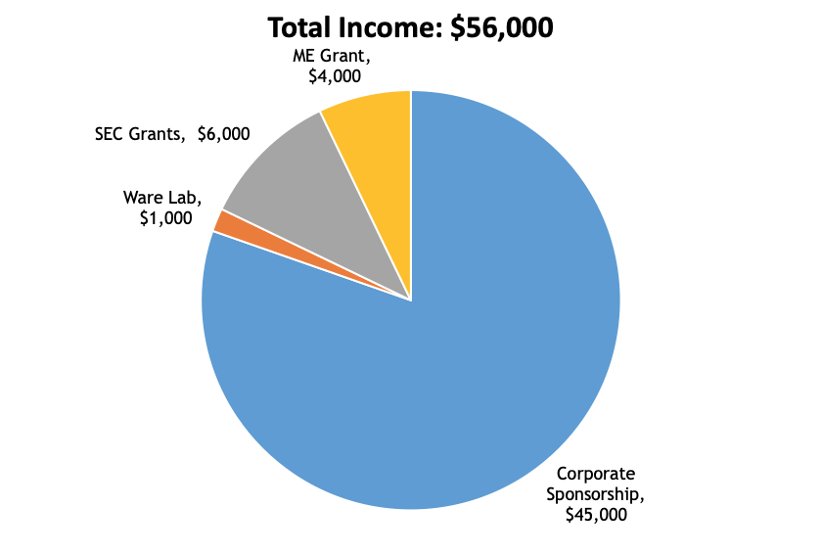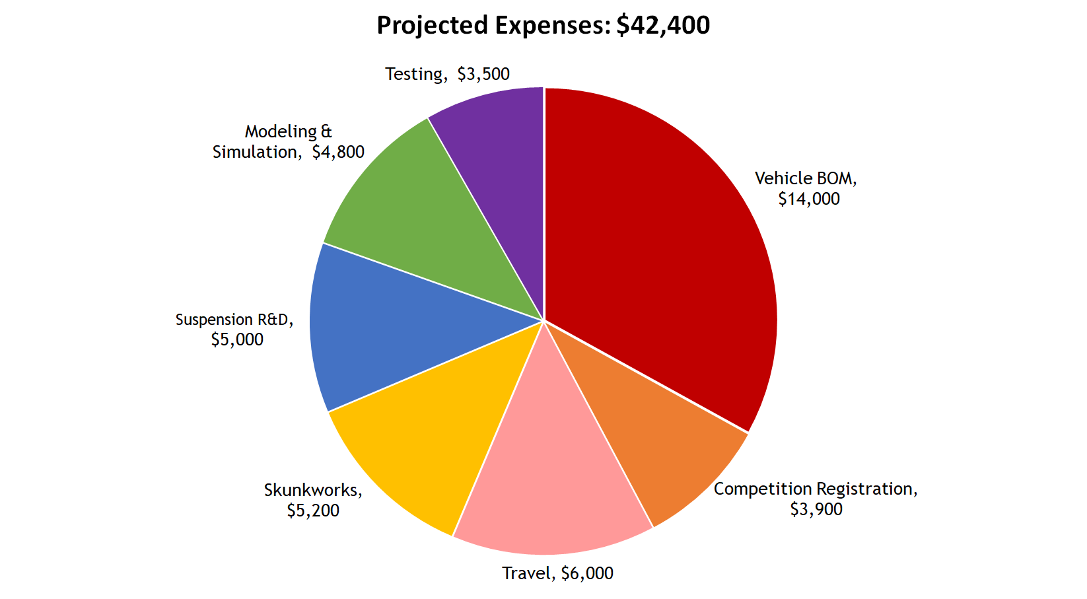

**Figure 26.** Total Income Budget of the 2018-2019 Baja Team.

**Figure 27.** Projected Expenses Budget of the 2018-2019 Baja Team.

There is $5,000 provided to the Suspension sub-team, while the Skunkworks sub-team has access to $5,200. There is $3,500 budgeted to testing where the resources from testing will be primarily used for both the Skunkworks and Suspension sub-teams.

At the close of this 2018-2019 project, the Suspension sub-team allocated their portion of the budget to purchasing materials to build two rear suspension prototypes. This money was also allocated to the design and build of the spares for the three competitions, which the Baja team will be attending in the spring.

The Skunkworks sub-team allocated their portion of the budget to purchasing components for a custom electronic control unit, which will act as both a testing component, as well as the program for running the system. This money was also used in purchasing materials to build one prototype, as well as a budget for refinement. This will allow for the design to be optimized and continued, for future Baja Teams.

The team’s final financial standings have been calculated. The Suspensions sub-team has spent 100% of their budget to date. The Skunkworks sub-team has spent 58% of their budget to date, which is due to the use of a secondary drivetrain and the continuation of ECU integration for future years.

Other team expenses have come from the purchase of CarSim and SuspensionSim software licenses for the Modeling and Simulation sub-team. The Testing sub-team has also spent a portion of their budget on linear potentiometers and Beaglebone Black microcontrollers. These expenditures are within their allocated budgets. The testing sub-team has also allocate a portion of their budget to purchase the required testing sensors and equipment needed to build the required test rigs and test suites for testing both the Suspension and Skunkworks sub-team.

# **XVIII. Conclusion**

Both the Rear Suspension and Skunkworks sub-teams have shown that their chosen designs are fully completed and tested, however, without continued improvement, any system’s potential will never be realized within a competition setting. This has discouraged previous teams from pursuing large projects which cannot be completed in a single academic year. Our team has rejected this paradigm. Mentorship of underclassmen and thorough documentation will ensure these projects’ continued development, which is critical to our long term success. We hope to set a new standard for how our organization operates in every capacity and create a legacy which ensures the success of this team for years to come.

**XIX. References**

Suspension References

1. Animation of the H-Arm Suspension Design without the driveshaft <https://www.youtube.com/watch?v=-CEbE3b2phU>
2. Motion Study Constrained Animation <https://www.youtube.com/watch?v=WlnKr2QhiYw>
3. Chassis Twist Test <https://www.youtube.com/watch?v=23OxlISJgaU>

Skunkworks References

1. CarSim Powertrain Documentation: <https://www.carsim.com/downloads/pdf/CarSim_Math_Models.pdf>
2. CarSim Constant Radius Comparison Simulation: <https://www.youtube.com/watch?v=dXjeQCHUnE4>
3. CarSim Washing Machine Comparison Simulation: <https://www.youtube.com/watch?v=uGVUMP5wV0w>
4. CarSim Maneuverability Track Comparison Simulation:

<https://www.youtube.com/watch?v=G9w0M5EPOng>

1. Arduino ECU Output

<https://www.youtube.com/watch?v=xhcf3oNENsk>

**XX. Appendix**

**Suspension Appendices**

**Appendix A.** Rear Suspension Engineering Characteristics

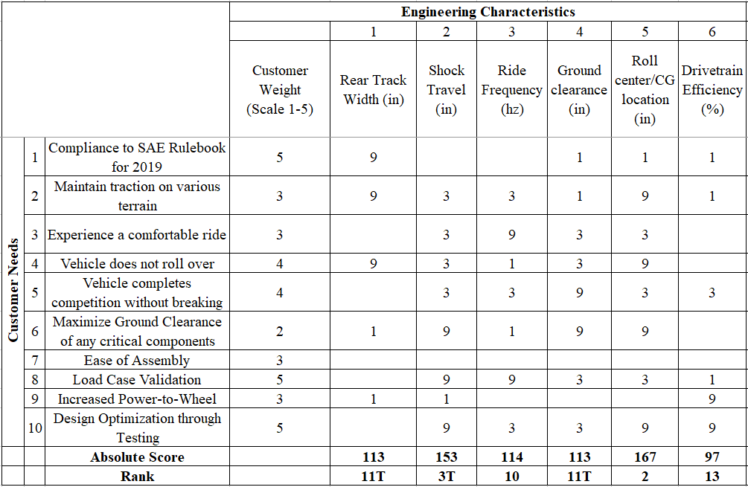

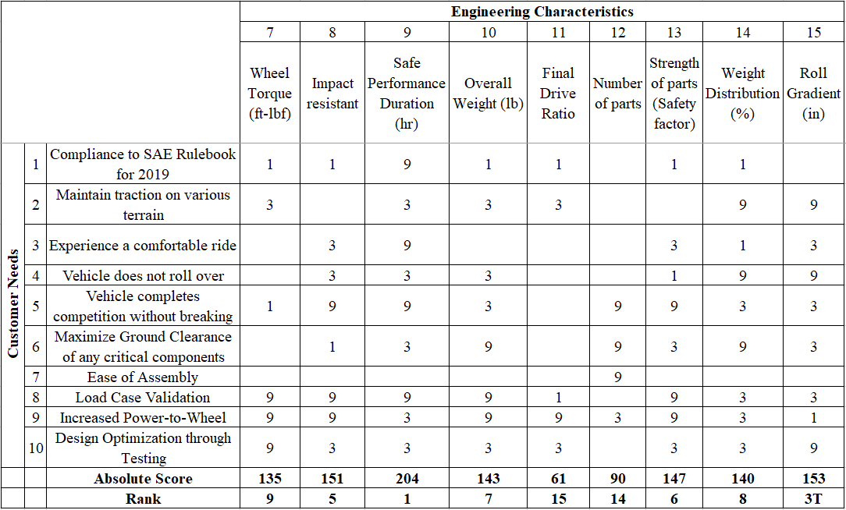

**Appendix B.** Suspension Down Selection Matrix

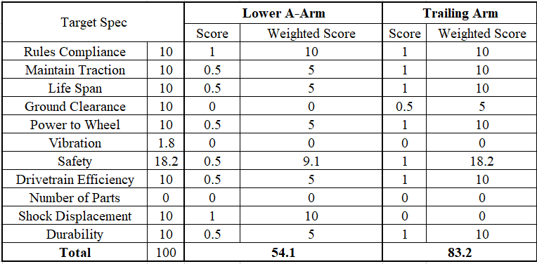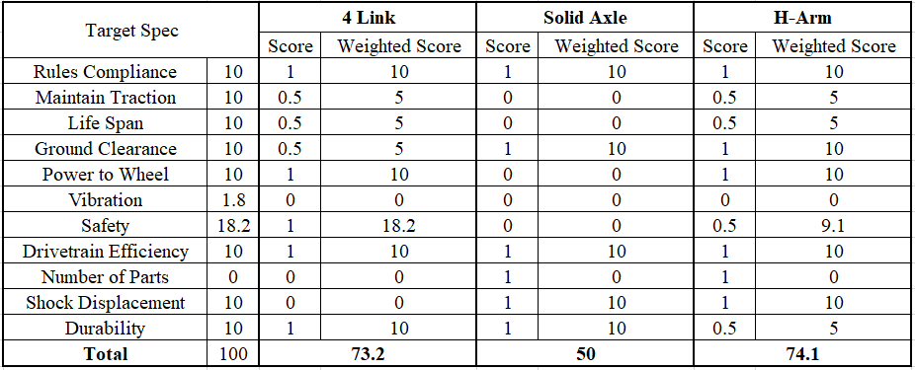

**Appendix C.** Rear Suspension Concept Down Selection Process

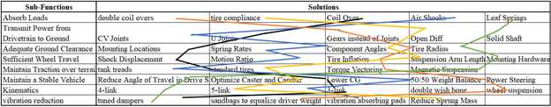

**Figure C.1.** Rear Suspensions morphological chart used in concept generation.

**Appendix D.** Suspension RAMP

**Risk and Mitigation Plan (RAMP)**

**Project Name:** Baja Suspension

**Project Number:** 46

**Introduction**

In this document, the Suspension team has determined the primary risks facing the H-arm concept the team has selected to pursue. The top five risks are explained, assigned a risk value, and minimized through a mitigation plan that has been developed for each one. Each of these risks are summarized for future reference.

**Risk 1: Half Shaft Shearing on Impact**

**Identifier:** Andrew Touzinsky

**Likelihood/Consequence:** 3:5

**Risk Level:** High

**Description:**

In years past, the issue has arisen of the main driveshaft of the vehicle being struck by an obstacle during one of the technical events. The halfshaft is the component that connects the output of the gearbox to the wheels.

**Basic Cause:**

The failure of the halfshaft is done normally by a rock or a misplaced log contacting the rotating component, and results in a catastrophic failure. It experiences a tremendous amount of torque due to its nature, and if contacted with an obstacle would bend, and subsequently shear.

**Impact:**

The failure of this component would immediately remove the vehicle from the race and would require lengthy fix process. The fix is also monetarily intensive, due to the nature of our current constant velocity joint design method. When each pair is purchased it cost around $800.

**Mitigation:**

We have kept spares of this component in the past, to ensure that this will not result in removing the vehicle from the competition permanently. Another method to mitigate this issue would be to increase the driveshaft ground clearance. This would be done by increasing the downward angle of the shaft and increasing the motion ratio of the shock. This would allow for a smaller cross-section where this component could encounter an obstacle.

**Mitigated Likelihood/Consequence:** 2:5

**Mitigated Risk Level:** Moderate

**Risk 2: Half Shaft Back Torque Failure**

**Identifier:** Andy Randell

**Likelihood/Consequence:** 3:5

**Risk Level:** High

**Description:**

Insufficient strength in the half shaft tubes, yokes, or welded joints could result in a shear failure during back torque resulting from jumping or other violent sudden movement during competition.

**Basic Cause:**

If proper modeling and design has not occurred or fabrication resulted in a flaw, either one or both sides of the driveshaft could fail due to fatigue and/or sudden loading during a high stress situation from back torque.

**Impact:**

This failure still results in the complete inability to drive and continue competition until the components have been repaired or replaced. This is time consuming and costly, and while the team will have spare components, the failure incurs a serious setback.

**Mitigation:**

Extensive modeling in CarSim and SuspensionSim to get load cases to use in ANSYS, as well as hand calculations and real-world testing, increasing factor of safety during design, and training drivers to not put the car into situations which cause significant back torque and unnecessary loading.

**Mitigated Likelihood/Consequence:** 2:5

**Mitigated Risk Level:** Moderate

**Risk 3: Poor Suspension Design**

**Identifier:** Aric Porter

**Likelihood/Consequence:** 3:3

**Risk Level:** Moderate

**Description:**

If our design process is flawed (rushed design cycle, neglected calculations, improper build, etc.), we could produce a suspension system that performs poorly. This could lead to decreased traction, less than maximum torque to wheel, lessened suspension travel, increased rollover likelihood, and poor ride conditions.

**Basic Cause:**

Carelessness in our design process, neglected calculations, rushed design cycle, improper build of components, and poor modelling are some base causes which could cause this failure.

**Impact:**

This failure would cause decreased performance at competitions, as well as other effects which were mentioned in the description.

**Mitigation:**

Increase modelling in CarSim and SolidWorks, as well as increase testing on previous vehicles to validate models. Thoroughly research suspension parameters and calculations to determine pertinent concepts for our design. Perform several mock design cycles (in computer software) to flesh out any mistakes in our design before Design Cycle 1. Testing of our actual design builds to validate models created during the cycle.

**Mitigated Likelihood/Consequence:** 1:2

**Mitigated Risk Level:** Low

**Risk 4: Hub Knuckle Deformation**

**Identifier:** Yuexiang Zhang

**Likelihood/Consequence:** 2:4

**Risk Level:** Moderate

**Description:**

The hub is the component that connects wheel and control arms of suspension. The potential failure is that the knuckles on the hub will deform, even break by various forces.

**Basic Cause:**

The deformation of knuckles mostly occur during the acceleration, de-acceleration or heavy burden due to both longitudinal forces, vertical forces and lateral forces because most of the forces (torsion) are carried by the hub, which result in catastrophic failure.

**Impact:**

The deformation of knuckles on the hub will directly result in the geometry change on the suspension, subsequently, wired wheel travel path. More severe result is the knuckles are broken and loss connection between control arms and wheels.

**Mitigation:**

The method to mitigate the issue is that use steel as the material to fabricate hub because steel is less likely warp, deform and bend under weight. Another method is that reduce the unsprung mass to decrease total moment of inertia of the car.

**Mitigated Likelihood/Consequence:** 1:2

**Mitigated Risk Level:** Low

**Risk 5: Rear Chassis Mounting Failure**

**Identifier:** Joshua Clark

**Likelihood/Consequence:** 2:4

**Risk Level:** Moderate

**Description:**

To accommodate our design, we will utilize a rear chassis that is compatible with mounting both of our potential concepts. Analysis must be thorough to ensure that the chassis can accommodate loading from either of our designs. A failure could mean yielding of the chassis tubing, which would be a lengthy and required fix to resume competition.

**Basic Cause:**

Neglecting to assess ideal mounting points for both potential designs, poorly constrained FEM, or carelessness.

**Impact:**

This failure would be a lengthy fix at competition. The time spent to repair mounting tabs and/or chassis members greatly reduces time on track in an endurance race. Future structural integrity of the chassis could be compromised.

**Mitigation:**

Ensure that at this point in the design cycle, both concepts are considered in the chassis design. Do not assume that we will mitigate enough of the risks associated with the "riskier" design by our cutoff. Be thorough in all calculations and FEA so that there is no doubt that both designs are acceptable with our chassis.

**Mitigated Likelihood/Consequence:** 1:4

**Mitigated Risk Level:** Low

**Appendix E.** Rear Suspension Current Gantt Chart

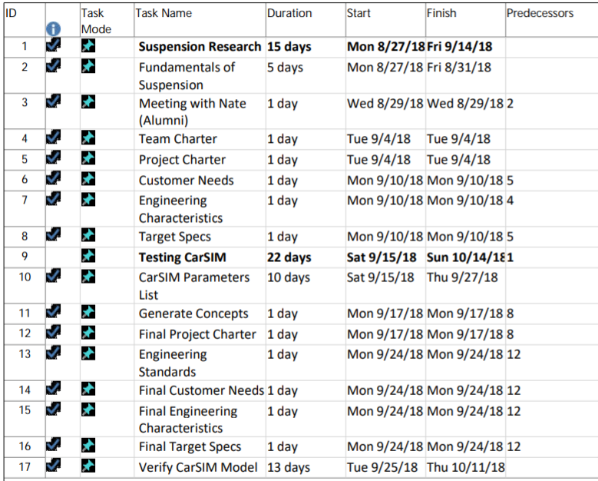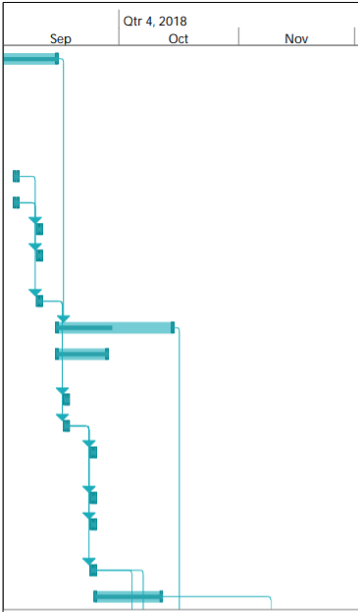

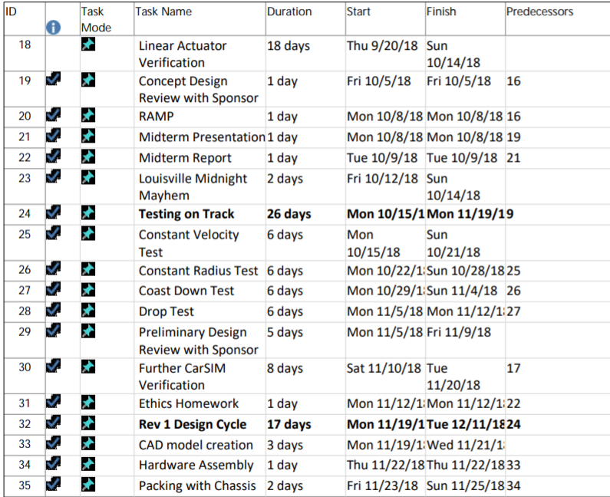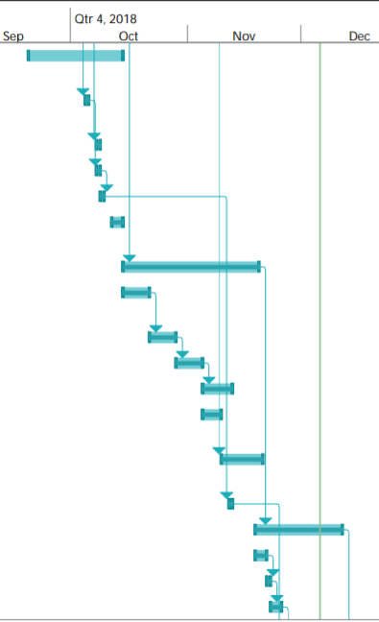

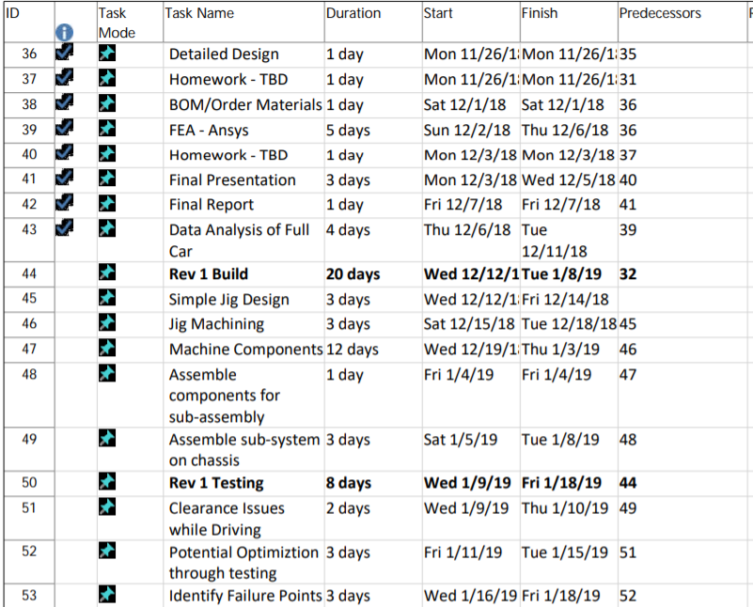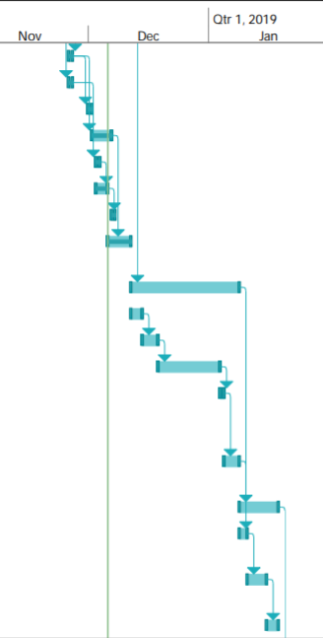

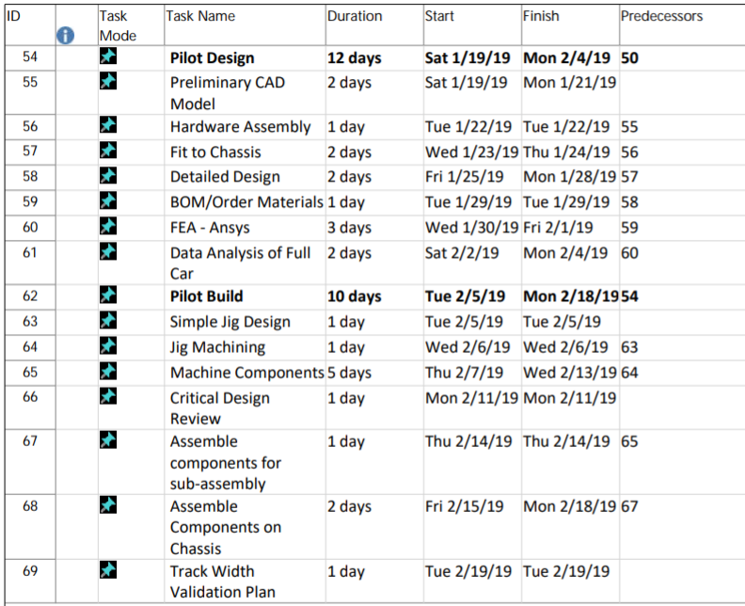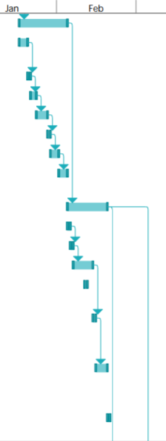

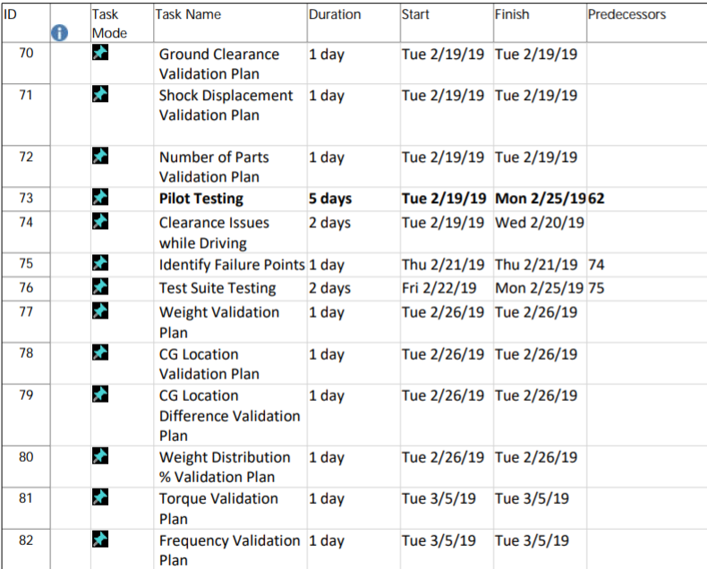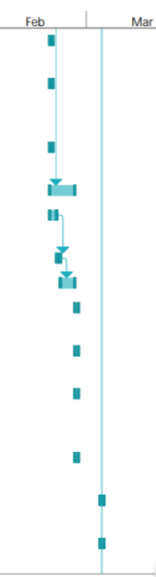

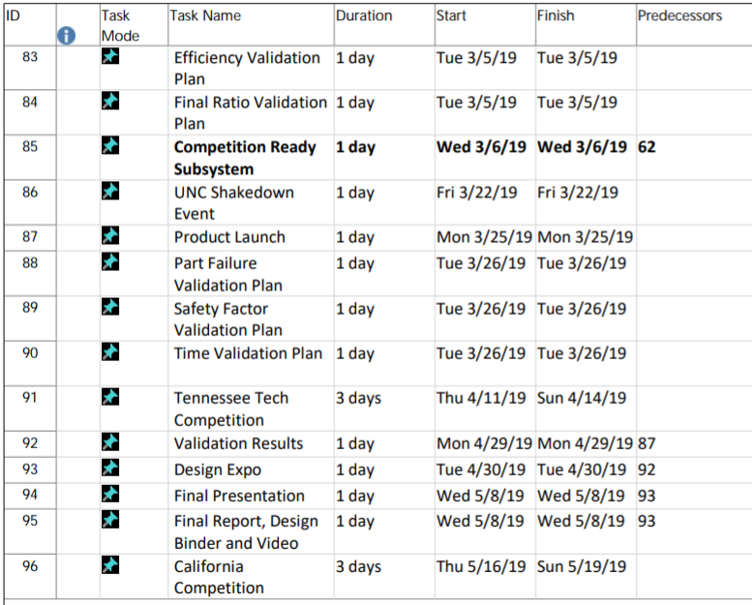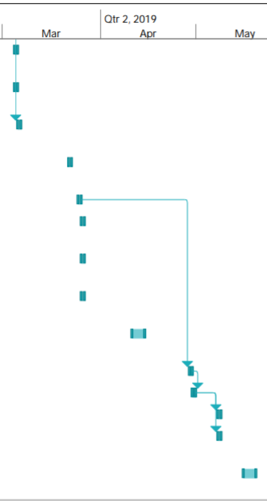

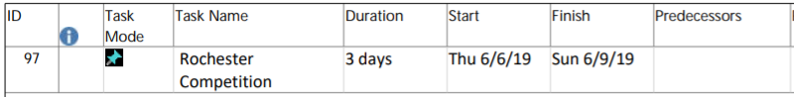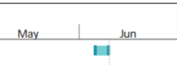

**Appendix F.** Melding Research and Development

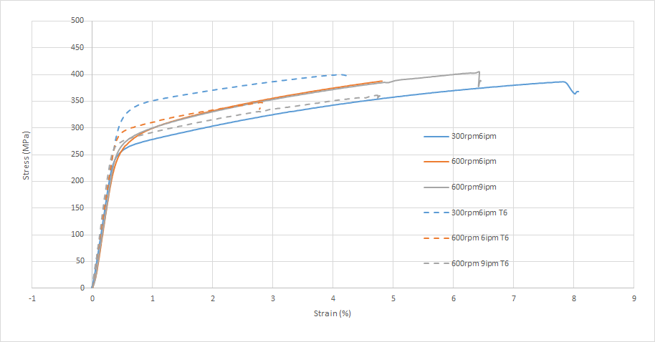

**Figure F.1.** Melded 7075 Stress Strain Curve for 3 different machine RPM settings

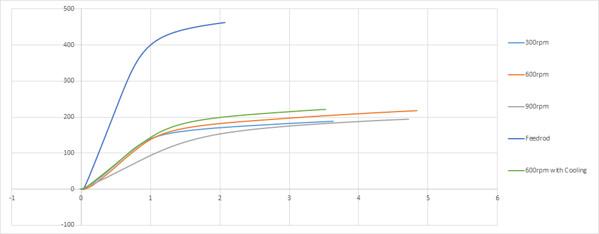

**Figure F.2.** Melded 6061 Stress Strain Curve for 3 different machine RPM settings

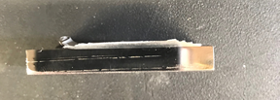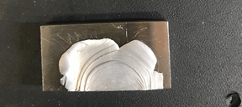

**Figure F.3a and 3b.** Aluminum on Steel Cross Section [Left] Aluminum on Steel Top View [Right]

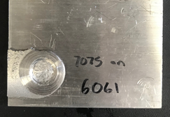

**Figure F.4a and 4b.** 7075 on 6061 Cross Section [Left] 7075 on 6061 Top View [Right]

**Appendix G.** Suspension Geometry and Kinematics

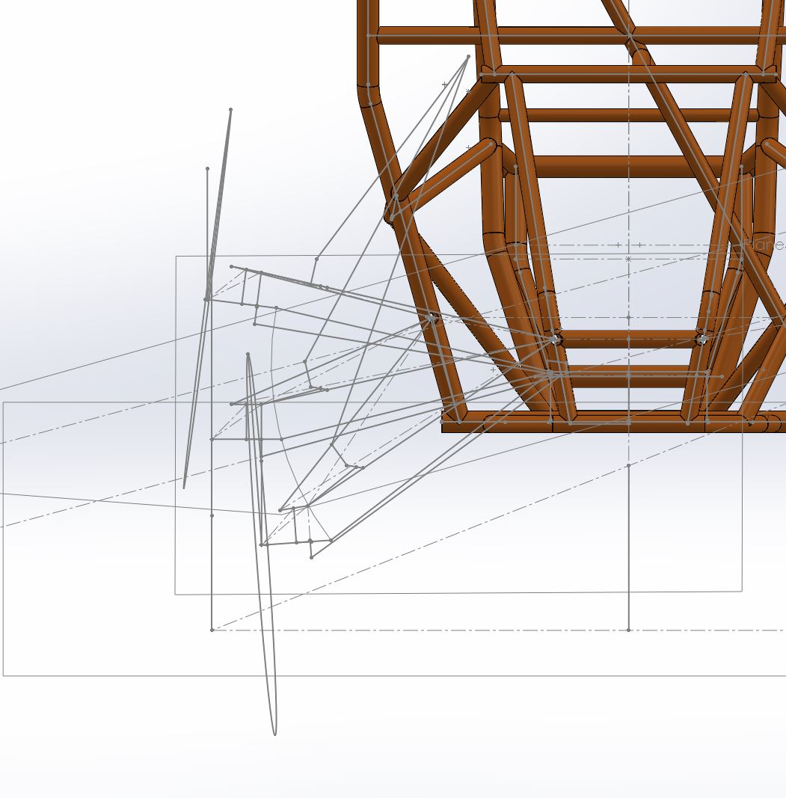

**Figure G.1** Kinematic 3D Sketch of the 2019 Suspension Design

**Appendix H.** Rear Suspension Allocated Budget

**Table H.1** Rear Suspension Budget Allocation to the different Components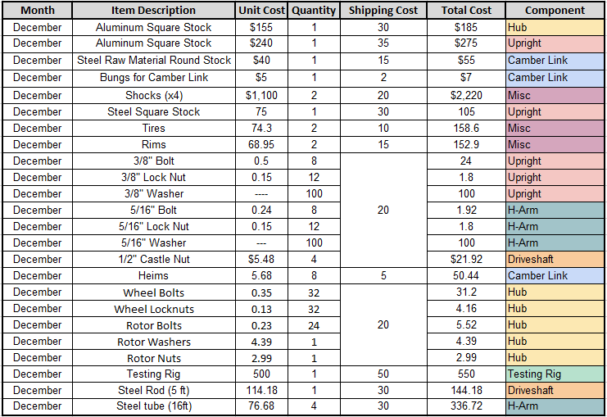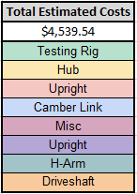

**Appendix I.** Skunkworks Customer Needs

**Table I.1.** Skunkworks Customer Needs and Engineering Characteristics Matrix Section 1.

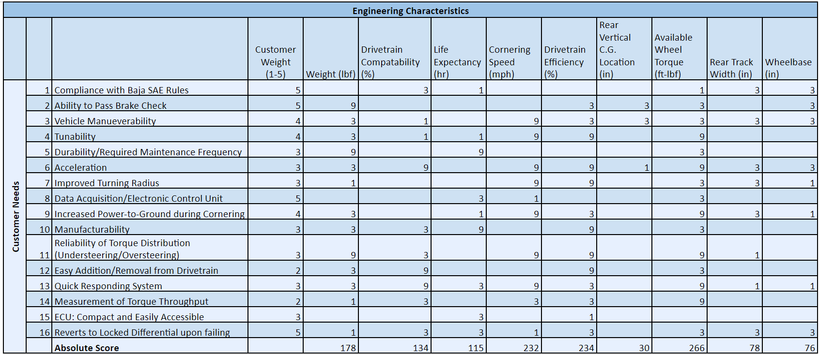

**Table I.2.** Skunkworks Customer Needs and Engineering Characteristics Matrix Section 2.

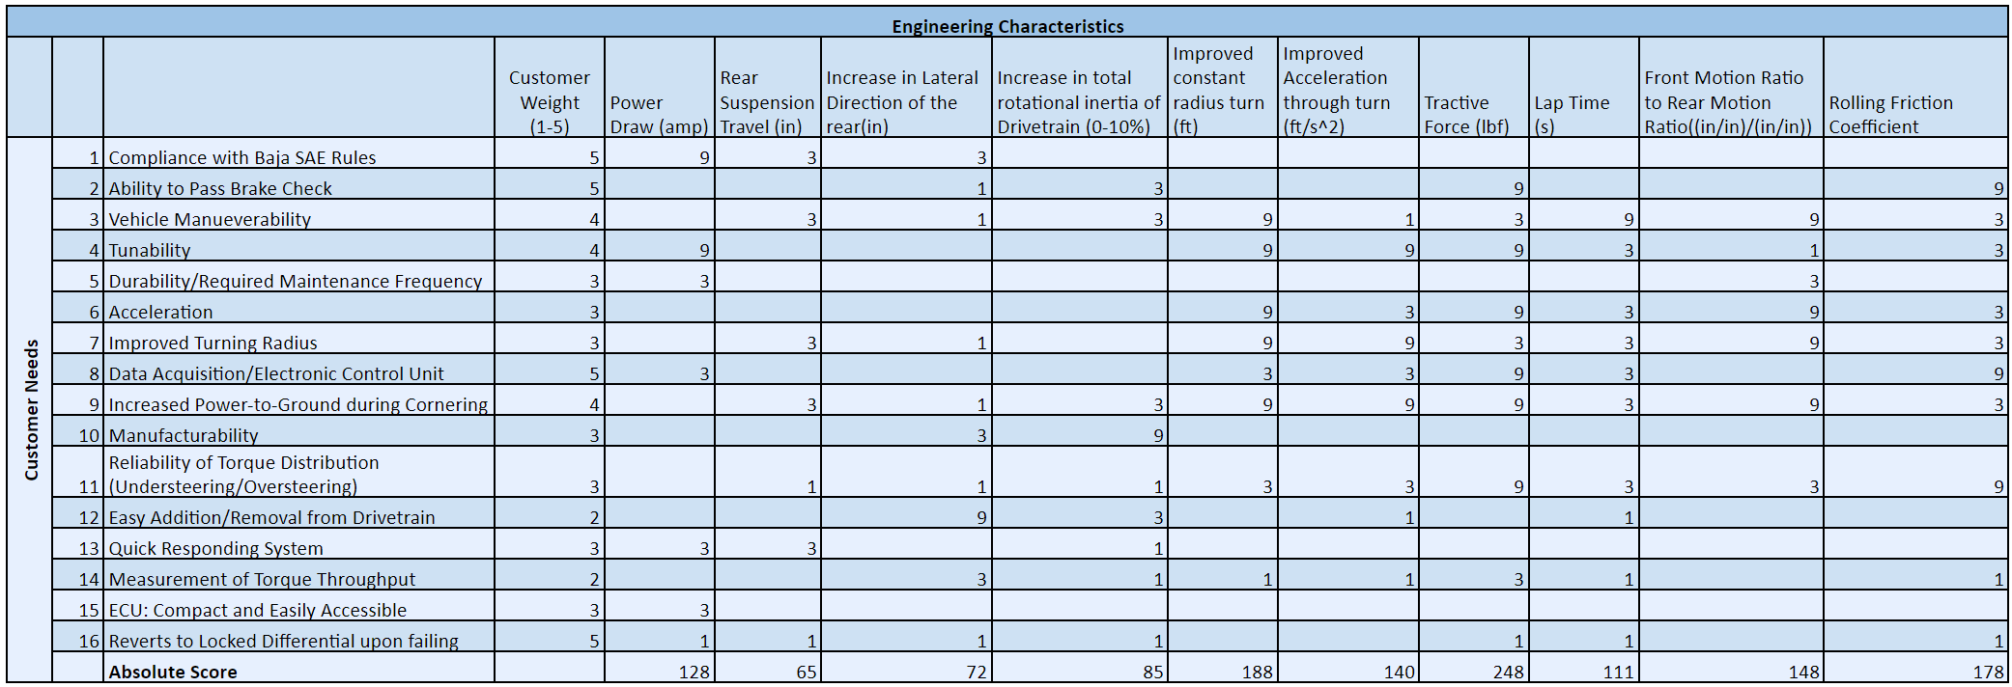

**Appendix J.** Skunkworks Concept Selection

**Table J.1.** Skunkworks Pairwise Comparison Chart  
.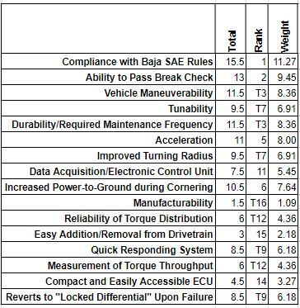

**Table J.2**. Skunkworks Concept Scoring - Selection Matrix

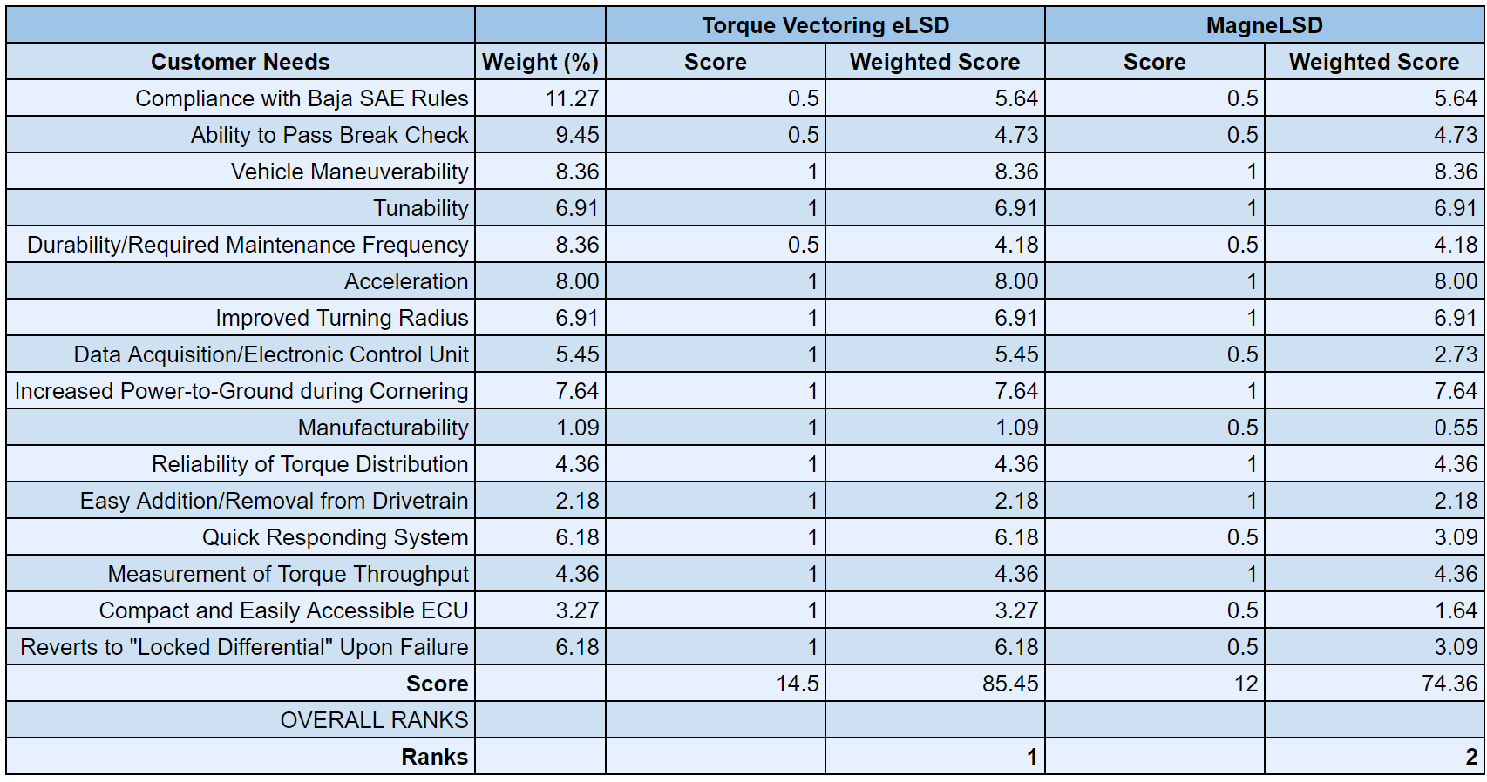

**Appendix K.** Skunkworks RAMP

**Risk and Mitigation Plan (RAMP)**

**Project Name:** Baja Skunkworks

**Project Number:** 46

**Introduction**

In this document, the Skunkworks team has determined the primary risks facing the electronic limited slip differential the team has selected to pursue. The top five risks are explained, assigned a risk value, and minimized through a mitigation plan that has been developed for each one. Each of these risks are summarized for future reference.

**Risk 1: Electronic Control Unit Failure**

**Identifier:** Matt Euliano

**Likelihood/Consequence:** 2:4

**Risk Level:** Moderate

**Description:**

The ECU is used to actuate torque output to the wheels, which could malfunction during use. This could be caused from several factors, including disconnection of wires, excessive temperature, excessive vibration, and improper sealing of the housing.

**Basic Cause:**

Over time, wear and tear will break the seals surrounding the ECU, allowing moisture to enter and corrosion to form on the interior components. These failures could occur due to a improper placement of the ECU. This placement could allow for excessive vibration to produce noise in the readings, which would cause inaccurate responses from the limited slip differential.

**Impact:**

This failure will result in a loss of traction control in addition to unpredictable response from the differential due to the inability of the limited slip differential to adjust wheel torque. This is significant for Baja endurance competitions that typically last multiple hours on rough and unpredictable terrain.

**Mitigation:**

To ensure that the ECU is not the limiting factor during endurance races, extensive finite element analysis will be conducted for the ECU casing. Additional reinforcement of the watertight seals that surround the ECU will be applied, preventing moisture from accessing the interior components. In the unlikely event of ECU failure, a failsafe is implemented that will effectively lock the axles together to ensure the safety of the driver. A relay will be installed to ensure that the system works properly, in the event that the ECU seizes operation.

**Mitigated Likelihood/Consequence: x:2**

**Mitigated Risk Level:**

**Risk 2: Sensor Communication Malfunction**

**Identifier:** Nadja Ross

**Likelihood/Consequence:** 2:5

**Risk Level:** Moderate

**Description:**

The sensor is used to communicate the amount of torque needed in each wheel to prevent slipping. A communication malfunction can be caused from a fault in the sensors or connections.

**Basic Cause:**

Connections and communication malfunctions can be caused from wear or breaks in the sensors. The vehicle experiences rough road conditions, therefore the sensors and connections need proper housing and protection. The excessive vibration of the vehicle could cause sensors to become uncalibrated, which would be a type of malfunction.

**Impact:**

Misreadings can cause an improper torque transfer between the two wheels, giving too much or too little torque to either of the wheels. This could cause the car to be undrivable and unsafe to the driver. Furthermore, the car could be deemed inoperable, if the sensor malfunction is determined as catastrophic.

**Mitigation:**

Ensuring the sensors are properly connected when first implemented is important to avoid initial performance issues. Proper protection of the sensors is also important as they will face harsh weather and road conditions. If the sensors do fail, the eLSD should reverts to a locked differential.

**Mitigated Likelihood/Consequence: x:2**

**Mitigated Risk Level:**

**Risk 3: Driveshaft Torque Failure**

**Identifier:** Yash Sharma

**Likelihood/Consequence:** 3:4

**Risk Level:** Moderate

**Description:**

Uncontrolled torque vectoring through the limited slip differential could result in a failed driveshaft during torque transfer from one wheel to the other or a sudden change in output. This sudden change in output could cause the system to apply a large amount of torque, shearing the driveshaft

**Basic Cause:**

If fail-safes are not implemented into the limited slip differential, to avoid the sudden application of torque after a sudden change in output (i.e. landing after a jump). This failure could also occur if proper analysis of the shafts with a torque higher than anticipated is delivered to the shaft (i.e. turning will induce >50% available torque to one wheel)

**Impact:**

This failure results in the elimination of power delivery from the powertrain to the wheels. In competition, this would require a tow off of the competition track back to the paddock. Due to the complexity of the limited slip differential, this could cause a relatively large loss in time and resources to repair the issue.

**Mitigation:**

The system will be modeled in Simulink, which will operate with CarSim to generate and evaluate realistic load cases that the system could potentially see. Proper finite element analysis and testing will be conducted, to draft realistic load cases for the driveshafts. The factor of safety of the driveshafts will be increased, to ensure that the driveshafts are not the limiting factor.

**Mitigated Likelihood/Consequence:** x:4

**Mitigated Risk Level:**

**Risk 4: Product Delivery Schedule**

**Identifier:** Yash Sharma

**Likelihood/Consequence:** 4:5

**Risk Level:** Low

**Description:**

There is a likelihood that the limited slip differential system may not be implemented on the mule vehicle or on the competition vehicle, which would defeat the purpose of this project.

**Basic Cause:**

Attempting to over-design the product could result in a drawn-out design stage, which would be terminal. Being unable to test at a component and vehicle level and improve the solution is another possible cause of failure. Establishing the improvement in performance over the conventional driveline solution is crucial.

**Impact:**

Being unable to deliver a product to the team and our customers will be seen as a failure of the project and will lead to dissatisfied team members and lowered team morale.

**Mitigation:**

Design and manufacture of the testing rigs in parallel to product design. Assuming that there will be delays in the schedule and working ahead when possible to offset those deslays will be crucial. Foresight in ordering of materials and their lead times will also help finish the project on time.

**Mitigated Likelihood/Consequence: x:1**

**Mitigated Risk Level:**

**Risk 5: Gear Failure**

**Identifier:**

**Likelihood/Consequence:** 2:4

**Risk Level:** Moderate

**Description:**

Three gear failures could occur, depending on the design of the system. Excessive wear in the bevel gears of a system could cause the system to seize and fail in the housing. Excessive wear and back torque experienced in the secondary gearbox, which distributes power from the main gearbox to the system, could cause the spur gears to fail. The main gearbox itself could fail, due to back torque or excessive loading from the system. Any of these could lead to a catastrophic failure and cause the car to be inoperable.

**Basic Cause:**

Excessive back torque, when landing after a jump, could cause the integrity of the gears to fail. Improper torque distribution from the differential could cause the differential to react suddenly and fail. Excessive wear, due to undersized/oversized gears and choice of gear oil, could cause a gearbox failure.

**Impact:**

If any of these gear failures were to occur, the car would need to be removed from the track and further inspected. This would be costly in time and placement, as well as increases the potential for further damage to the vehicle outside the subsystem.

**Mitigation:**

Increase the factors of safety of each gear in the gearboxes, allowing for excessive loading to be taken into account. Increasing the overall analysis of the gears, to ensure the failure modes are contained within the subsystem and easily replaceable. Furthermore, sensors will allow for the tracking of the system, to determine life and potential concerns in the data.

**Mitigated Likelihood/Consequence: x:4**

**Mitigated Risk Level:**

**Appendix L.** Skunkworks ECU Software and Hardware Development

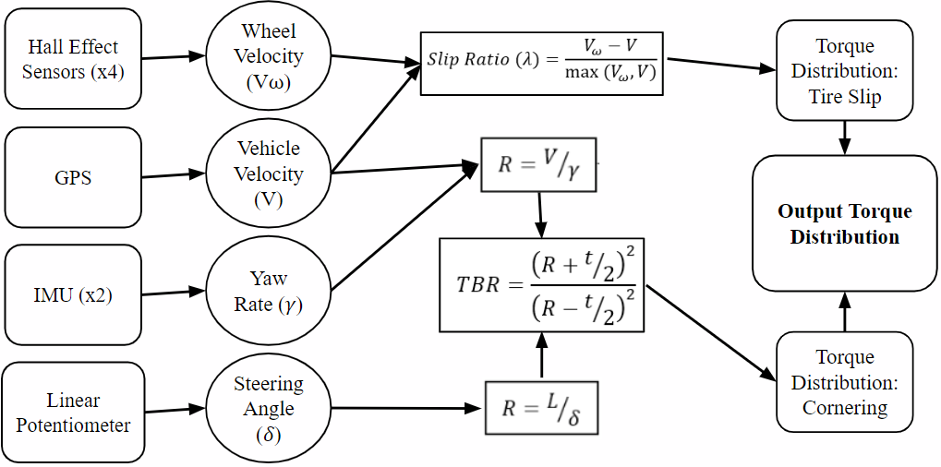

**Figure L.1.** Flow Diagram displaying ECU development process

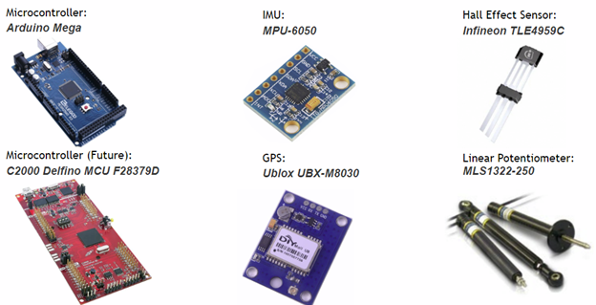

**Figure L.2.** ECU Hardware Selection

**Appendix M.** Skunkworks Validation Plan

**Validation Plan – Available Wheel Torque**

**Introduction**

**Purpose** This validation plan will be used to evaluate the performance and durability of the Electronic Limited Slip Differential. This validation plan is of high importance, due to the loads the differential can endure during competition, as well as assigning appropriate values to the models, to ensure proper finite element analysis and material selection. This validation plan will outline the strategy, resource requirements, and acceptance criteria, as well as the type of testing method and its significance, detailed step-by-step procedure, explanation of data collection methods, and the required safety precautions. This information will allow for the verification of the component’s performance, when comparing the acceptance criteria to the value acquired.

**Definitions, Acronyms, Abbreviations**

**ECU –** Electronic Control Unit: Microcontroller that actuates the clutch packs in the eLSD **eLSD –** Electronic Limited Slip Differential: Advanced differential controlled by an ECU

**FEA –** Finite Element Analysis: Simulation software that determines failure points

**TTR –** Torque Testing Rig: Testing Setup for differential components

**Type of Testing Method and its significance**

· Using two Hall-Effect Sensors to determine the speed of a metallic disk with imbedded magnets.

o The use of two sensors, rather than one sensor, will allow for redundancies in the logic.

o These redundancies will allow for a sufficiently robust logic.

· In determining the speed of the shaft, we correlate this information to the Engine RPM curve to determine torque.

· The significance of this information is the eLSD will need to adjust the torque to each wheel through turns.

· In addition, the knowing of available wheel torque will allow for the extremes of torque split to be known (i.e. 80% torque in left wheel, 20% torque in right wheel).

**Detailed Step by Step Procedure**

1. Manufacture Aluminum Disks that can be mounted onto the output shaft.

2. Machine spokes into the aluminum disks, to ensure separation in readings by the hall-effect sensors.

3. Imbed two magnets, 180 degrees from each other on aluminum disk.

4. Manufacture two mounts for the hall-effect sensors, to ensure rigidness and accuracy in readings.

5. Mount Hall-Effect Sensors in their respective locations on the Torque Testing Rig.

6. Wiring Hardware into the DAQ.

7. Calibrating Data from sensors, to ensure accurate readings.

8. Run the TTR and begin acquiring data.

9. Fluctuate the Throttle Cable, following a slow increase from 0% throttle to 100% throttle over 10 seconds.

10. Post Process Data and Graph, to develop a relationship between the engine rpm and available wheel torque.

**Explanation of Data collection Methods**

· The Hall Effect Sensors measure changes in magnetic field.

o In utilizing aluminum disks with imbedded magnetics, the change in magnetic field can be measured.

o Using Hall-Effect Sensors with a Schmitt trigger allows for absolute readings from the sensors, meaning it outputs either logic high or logic low.

**Required Safety Precautions**

· Full Shield surrounding the TTR, to ensure safety in the event of a failure.

· Safety Glasses will be used throughout the entirety of testing.

· Fire Extinguisher prepared, in the event of a fire.

**Appendix N.** Skunkworks Gantt Chart

**Table N.1.** Skunkworks Gantt Chart Section 1.

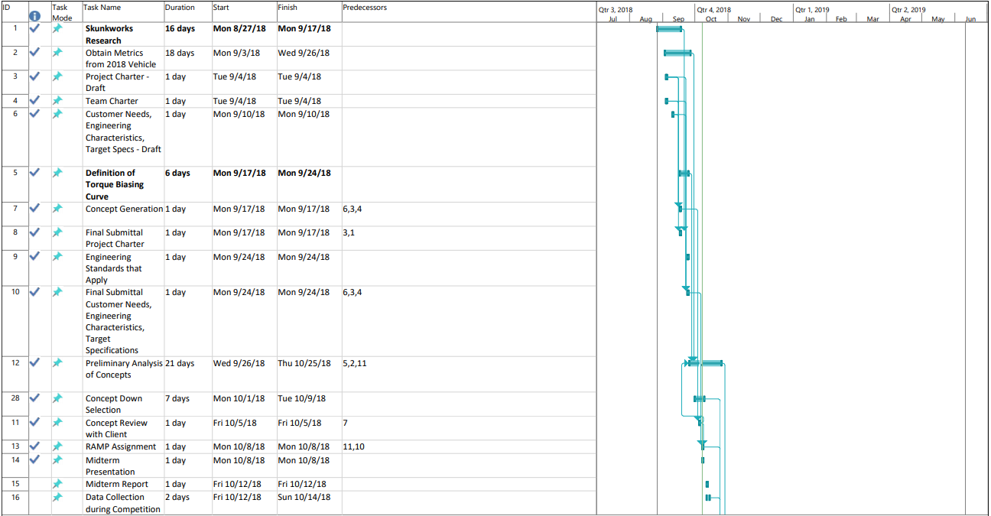

**Table N.2.** Skunkworks Gantt Chart Section 2.

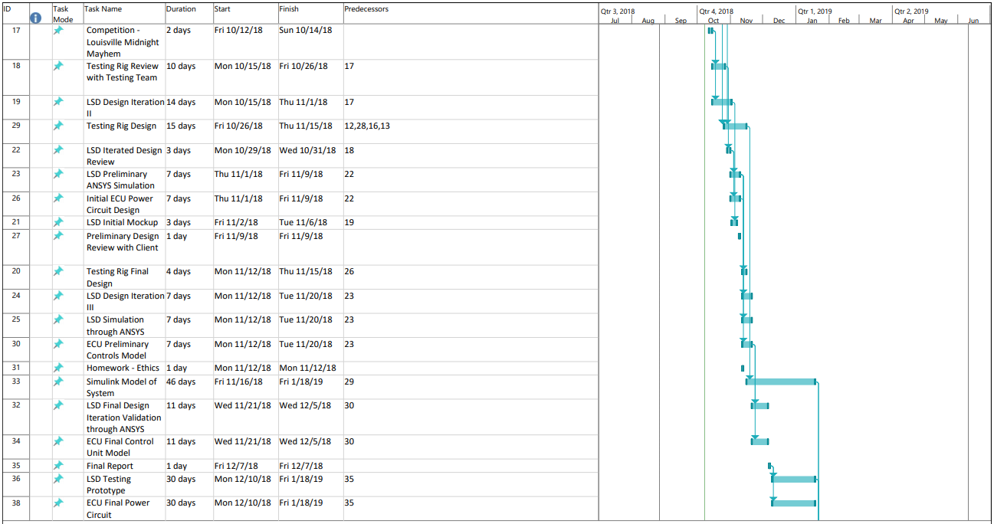

**Table N.3.** Skunkworks Gantt Chart Section 3.

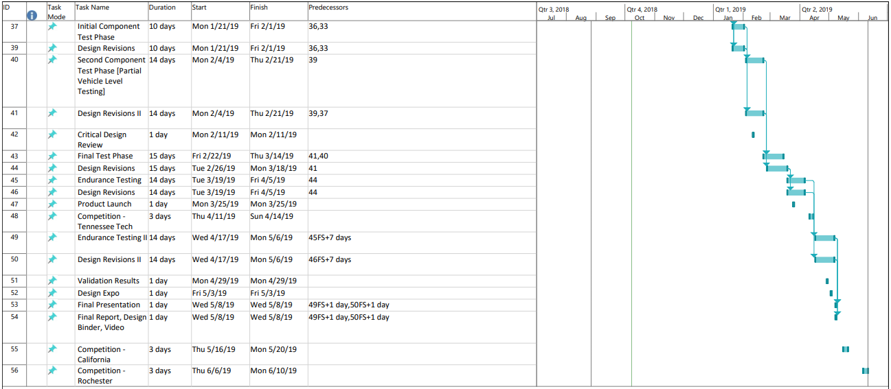

**Appendix O.** Skunkworks Testing and Validation Plots

**Table O.1.** Skunkworks Target Specifications Results

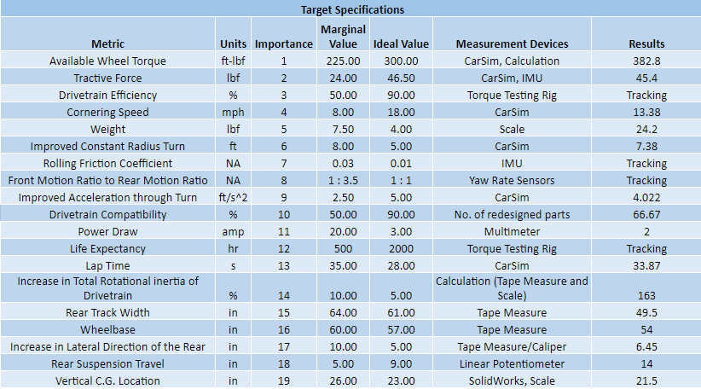

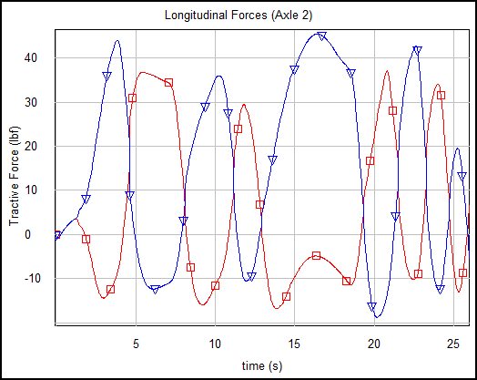

**Figure O.1.** CarSim Plot of Tractive Force on Right (blue) and Left (red) tires

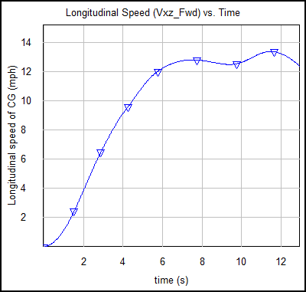

**Figure O.2.** Cornering speed from CarSim

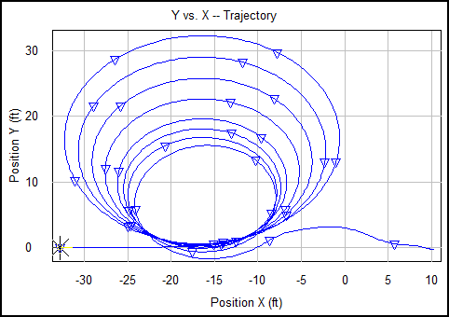

**Figure O.3.** CarSim constant radius test

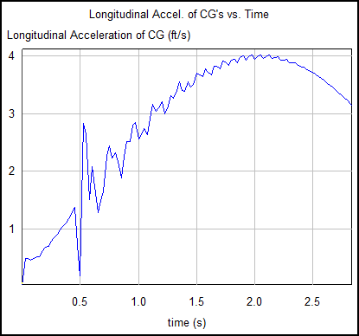

**Figure O.4.** Improved acceleration through turn found through CarSim simulation